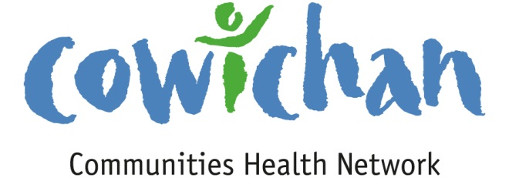

CHECK UP
September 13, 2013
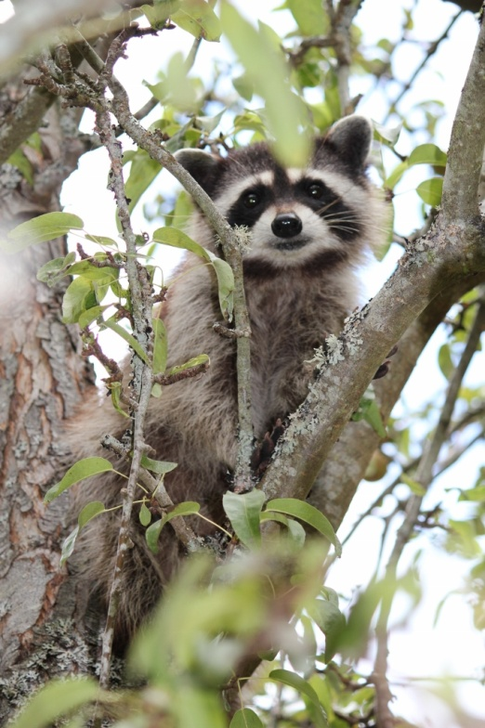

This little bandit was enjoying the apples right out of the tree. He reminds us all to embrace the fall harvest season and eat lots of fruits and vegetables!

Today’s Check up Includes:

- Meeting Schedules
- Community meetings and Events
- Underlying Premise Evidence- (part 9) Biology and
Genetic Endowment
- Towards a More Equal Canada

CCHN Network Member Meetings-
- Next CCHN Meeting September 12th, Dinner at 5:30 Meeting Starts at 6:00- CVRD Board Room
- Admin Committee Meeting September 19 at 5:30 CVRD Committee Room 2
Upcoming Events/ Workshops/ Community Meetings

Terry Fox Run September 15 Forest Discovery Centre-
Registration at 9:00 race starts at 10:00. You can run 10 km, 6 km or bring the children for the 1 km trot.

Great Lake Walk – Cancelled this year

Family Meals Event Friday October 4th at Clements Centre- bring your children to enjoy a free family meal. Doors open at 4:30- Dinner starts at 5:00 and activities follow.

KEY DETERMINANT – 9 Biology and Genetic Endowment
UNDERLYING PREMISES

EVIDENCE
The basic biology and organic make-up of the human body are a fundamental determinant of health.
Genetic endowment provides an inherited predisposition to a wide range of individual responses that affect health status. Although socio-economic and environmental factors are important determinants of overall health, in some circumstances genetic endowment appears to predispose certain individuals to particular diseases or health problems.
Evidence from the Second Report on the Health of Canadians

Studies in neurobiology have confirmed that when optimal conditions for a child's development are provided in the investment phase (between conception and age 5), the brain develops in a way that has positive outcomes for a lifetime.
Aging is not synonymous with poor health. Active living and the provision of opportunities for lifelong learning may be particularly important for maintaining health and cognitive capacity in old age. And studies on education level and dementia suggest that exposure to education and lifelong learning may create reserve capacity in the brain that compensates for cognitive losses that occur with biological aging.

Towards a More Equal Canada

Towards a More Equal Canada
This report is part of the Broadbent Institute’s Equality Project. Launched in the spring of 2012, the project includes a Broadbent Institute-commissioned Environics poll which showed a majority of Canadians support taking action to reduce inequality, a social media campaign, and an animated video. Find the Equality Project at http://www.broadbentinstitute.ca, and please share it broadly.

Do you have a resource, event or information you would like to share?
Send it to cindylisecchn@shaw.ca and it will be included in the weekly Check UP Newsletter

Sponsored by the Network for Families Group
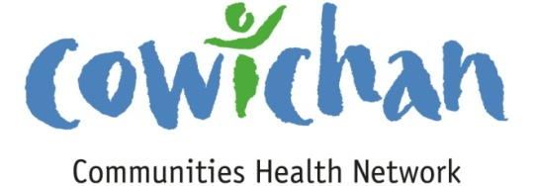

Friday October 4th
at Clements Centre
5856 Clements Street, Duncan
Doors open at 4:30. Dinner at 5:00 – Activities to follow
Bring your children to enjoy a free
Family Meal
Eat together, listen to a story
Activities for children & parents to enjoy together.
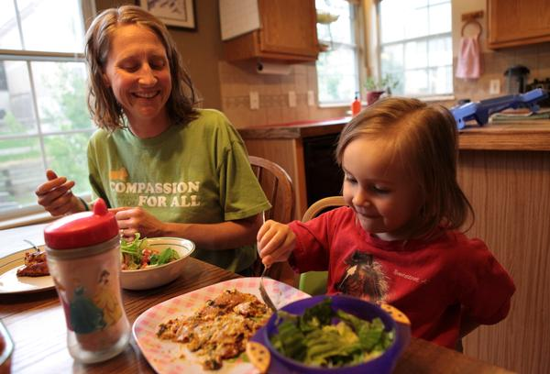
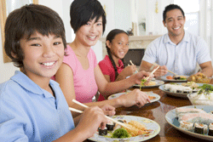
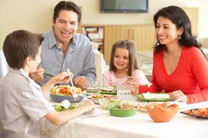
Children who eat with their family Members at least once a day:
Communicate better with their parents
Practice their social skills
5856 Clements Street
Deepen their sense of belonging and security
Do better at school
Eat more vegetables, fruit and calcium rich foods
Learn more words, have a better vocabulary

More Information:
Margaret Moss Health Centre
250-709-3050 local 45509

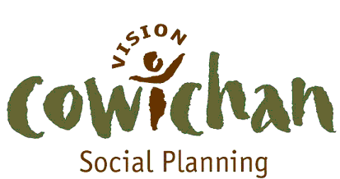

Care Kits

HOMELESSNESS ACTION WEEK 2013
A Day of Direct Services for the Homeless

Wednesday October 16, 2013 - 10:00 am to 3:00
Duncan United Church Hall

Our intent is to bring together government services, not-for-profits, community services, and individual volunteers in a coordinated effort to support those who are most vulnerable in our communities.
A variety of personal care items, clothing and sleeping gear will also be available for guests.

Care Kits:
- Socks , Tooth Brushes, Toothpaste, Soap, Lotion, Shampoo, Lip balm, Combs
- Seasonal clothing: Jackets, hats, scarves, mitts, rain gear,
- Work Clothing
- Blankets
- Tents
- Sleeping Bags
- Boots
- Back Packs
- Sewing Kits
- First Aid Items
- Foot wear
- Feminine hygiene products
- Books
- Granola Bars, Juice Box
- Flashlights
- Razors
- Nail Clippers

Items may be dropped off to Social Planning’s office at 135 Third St.
A donation box is inside the upstairs front door.
We are anticipating 60 to 80 guests. Items will be displayed and they can pick out items of their choosing.

