CHECK UP
October 4, 2013

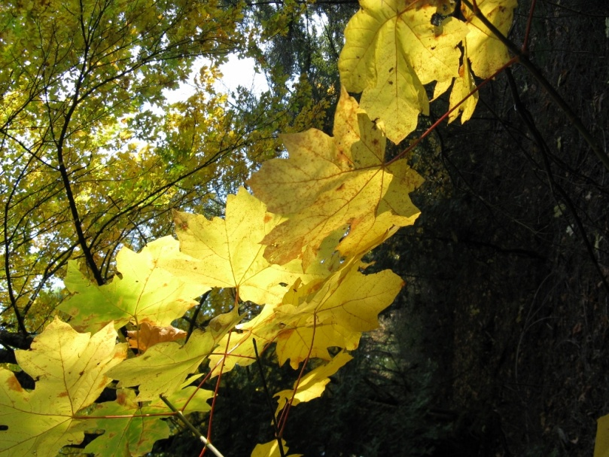

Today’s Check up Includes:

- Meeting Schedules
- Community meetings and Events
- Underlying Premise Evidence- (part 12) Culture
- Building a Neighbourhood Hub- contest -needs your vote
- Parasport Jumpstart Announcement
- UBC Indigenous Learning Circles- on line workshops and webinars
- South Cowichan Seniors News letter and event schedule- see attachment
- Cities Fit for Children Conference

CCHN Network Member Meetings-
- Asset Mapping and Research Committee Meeting October 7, 9:00 am Committee Room 2
- Next CCHN Meeting October 10th, Dinner at 5:30 Meeting Starts at 6:00- CVRD Board Room- Please RSVP
- Admin Committee Meeting October 16th at 5:30 CVRD Committee Room 2

Upcoming Events/ Workshops/ Community Meetings

Family Meals Event Friday October 4th at Clements Centre- bring your children to enjoy a free family meal. Doors open at 4:30- Dinner starts at 5:00 and activities follow.
Seniors Meeting- Friday October 4th at St. John’s Hall First/ Jubilee Street 11:00 am to 12:30. Please join Cowichan Co-operative Connections' meeting for all Cowichan seniors and support agencies to discuss how an eldercare co-op might best address our needs in the valley. Funding for the planning and development of a co-op is currently available. The co-ordinator of this Canada-wide initiative will make a presentation prior to the community dialogue, so a large turn-out of seniors and senior-serving agencies will be valuable.
Questions? Rick@FreeRangeConsulting.ca

Homelessness Action Day -Wednesday October 16, 2013 - 10:00 am to 3:00 Duncan United Church Hall

KEY DETERMINANT – 12 Culture
UNDERLYING PREMISES

EVIDENCE
Some persons or groups may face additional health risks due to a socio-economic environment, which is largely determined by dominant cultural values that contribute to the perpetuation of conditions such as marginalization, stigmatization, loss or devaluation of language and culture and lack of access to culturally appropriate health care and services.
Evidence from the Second Report on the Health of Canadians

Despite major improvements since 1979, infant mortality rates among First Nations people in 1994 were still twice as high as among the Canadian population as a whole and the prevalence of major chronic diseases, including diabetes, heart problems, cancer hypertension and arthritis/rheumatism, is significantly higher in Aboriginal communities and appears to be increasing.
In a comparison of ethnic groups, the highest rate of suicide occurred among the Inuit, at 70 per 100,000, compared with 29 per 100,000 for the Dene and 15 per 100,000 for all other ethnic groups, comprised primarily of non-Aboriginal persons.
The 1996-97 National Longitudinal Survey of Children and Youth found that many immigrant and refugee children were doing better emotionally and academically than their Canadian born peers, even though far more of the former lived in low-income households. The study suggests that "poverty among the Canadian-born population may have a different meaning than it has for newly arrived immigrants. The immigrant context of hope for a brighter future lessens poverty's blows; the hopelessness of majority-culture poverty accentuates its potency."
- See also evidence from the report Improving the Health of Canadians

Community, School and Neighbourhood coming together – please watch the video and VOTE! ........This one is worth sharing.

Our children's school needs your help today and everyday to win a contest to get a playground. Please help us!

École Mt. Prevost PAC needs your help starting TODAY!
To build the dream....
To build a multi-generational playground at École Mt. Prevost Elementary.
The idea: To take a section of our empty field and build a playground for everyone.
Play equipment for students...
an outdoor classroom for teachers...
a community garden for neighbours...
an exercise area for seniors...
a sandbox for toddlers...
and a picnic space for everyone!
We need you to vote for our AMAZING idea... EVERY DAY!!
Register to vote at: https://www.avivacommunityfund.org/ideas/acf17520

The more votes, the better chance we win!
So, INVITE your FRIENDS & RELATIVES to VOTE too!
So that you remember...TO VOTE EVERY DAY!!
Please help us!!
Thank you so much, merci beaucoup à tous,
Sandrine
Parasport Jumpstart Announcement
OTTAWA, September 24, 2013 – Building on the strategic partnership announced earlier this year with the Canadian Tire Family of Companies, today the Canadian Paralympic Committee and Canadian Tire Jumpstart Charities announced the start of a new fund that will help more kids to get in the game.
The two organizations invite Canadian sport and community groups to apply for the inaugural Parasport Jumpstart Fund. The Fund, which is also supported by the Government of Canada’s Sport Support Program, will help cover the costs of sports and recreational programs for children between the ages of four and 18, who are financially disadvantaged and living with a disability.
“The Parasport Jumpstart Fund is a great initiative that will help more Canadian children with a disability get involved in organized and recreational sports,” said François Robert, Executive Director of Partnerships for the Canadian Paralympic Committee. “Jumpstart’s investment in grassroots sports programming is exactly what is needed to help grow parasport opportunities across the country.”
The Parasport Jumpstart Fund is intended to support the creation of a new program or go towards the expansion of an existing successful initiative. Funds may be used towards registration, transportation and equipment costs for children within approved parasport programs.
“Supporting the Parasport Jumpstart Fund will provide opportunities for young Canadians with disabilities to get involved in and develop through sport,” said the Honourable Bal Gosal, Minister of State (Sport). “Our Government is proud to play a leading role in the inclusion of people with disabilities in sport by supporting programs such as this. Our hope is that one day Canada will reap the benefits of this fund by seeing our youth become athletes who proudly wear the maple leaf on the international stage.”
“We are very excited to launch this fund in partnership with the Canadian Paralympic Committee so we can provide even more kids the chance to experience the benefits of organized sport and recreation,” said Johnny Misley, President of Canadian Tire Jumpstart Charities. “Organized sport and recreational activities teach young people critical life skills such as confidence and teamwork. Teaming up with the Canadian Paralympic Committee will allow us to assist families who have children with a disability to get active in their community.”
Canadian Tire Jumpstart Charities will be accepting applications to the Parasport Jumpstart Fund beginning September 25, 2013 and closing October 29, 2013. Funds will be allocated on a first-come, first-served basis.
For information on eligibility and how to apply, please visit: www.paralympic.ca/jumpstart
Lunch on Clements
Please find attached a copy of the menu for the daily lunch specials in October. Also, please note that reservations will be required for the Thanksgiving Hot Luncheon on Wednesday October 9th. The cost is $6.00 and can be reserved by calling 250-746-4135 Ext 243.

Lunch on Clements is a cafeteria style program supporting adults with developmental disabilities to develop the skills and customer service needed for greater independence in our community. We offer a daily lunch special (all prepared on-site with the freshest of ingredients) in addition to both individual and family catering.
We are located at 5856 Clements Street where we look forward to serving you ☺.
Lisa Chileen
Day Program Coordinator
Clements Centre Society
(250) 746-4135 Ext. 233

Indigenous Careers
The UBC Learning Circle is excited to announce two new Learning Circles highlighting career options for Indigenous adults and youth.
Ch'Nook Indigenous Business Education Program
Ch’nook is a unique initiative founded by the Sauder School of Business at the University of British Columbia in Vancouver in 2002. It was established to build the skills and capacities required to enable Aboriginal communities and their leaders to become equal partners in regional economic development near or on their traditional territories. This presentation will focus on providing an overview of the program's activities in the province of British Columbia. Its success is built on three pillars of engagement that ensure maximum benefits for Aboriginal participants: Aboriginal Management Certificate Program, Ch’nook Scholars and Ch’nook Cousins. More info...
Date: Tuesday, October 15, 2013
Time: 10 to 11 a.m.
Aboriginal Midwifery as a Career Choice
The Midwives Association Aboriginal Committee of the Midwives Association of British Columbia will lead an interactive and dynamic discussion regarding the important work that midwives and doulas carry out within their communities. This session will focus on the positive impact that re-shifting the childbirth culture has had on outcomes for maternal-infant health and explore bringing birth back to communities. The presenters will also discuss various conventional and traditional educational pathways that currently exist for youth interested in these professions. More info...
Date: Wednesday, October 16, 2013
Time: 10 a.m. to 12 p.m.
Registration
Join us live via videoconference OR computer webinar!
Want to know the difference between videoconference and computer webinar? Click here to find out.
Registration: Click here to register. Pre-registration is required attend this free live event.
Other Upcoming Learning Circles
Register to attend any or all of these *FREE* sessions. All times are 10 a.m. to 12 p.m. unless otherwise noted. More information about these sessions is coming soon.
October 1: Youth Learning Circle - Elder Gerry Oleman
October 2: Aboriginal Criminology Series: A Talk with Dr. Kim Rossmo (7 to 9 p.m.)
October 8: Feeding Your Family Delicious Food (Gerry Kasten, FNHA)
October 30: Aboriginal Midwifery (Midwives Association of BC)
November 5: Fantastic Foods for Babies (and Moms, too!) (Gerry Kasten, FNHA)
November 13: YouthCO presents "Contraception"
November 20: Healthy Eating for Wellness, Chronic Disease Prevention & Management (FNHA)
November 21: PHSA Aboriginal Safe Sleep Program
November 26: Trauma-Informed Practice with Indigenous Children and Youth (Natalie Clark)
December 3: Traditional Foods (FNHA)

November 21-22, 2013
Cities Fit For Children
Guilford Sheraton
Surrey, BC
From the Cities Fit for Children Planning Committee - We invite you to take part in the Cities Fit for Children 2013 Conference, November 21-22
Cities Fit for Children is a provincial summit to bring together municipal, child development, and other professionals together to share expertise and ideas in making communities fit for children and youth. We have an excellent program this year – featuring keynotes from Kerry Constabile (Specialist, Urban Planning & Programming at UNICEF), Dr. Trevor Hancock (University of Victoria), Mayor Dianne Watts, and a panel of research leaders including UBC and the McCreary Centre Society. Additionally, you can pick from nearly 30 workshop choices, including: the University of Auckland, David Suzuki Foundation, Equitas, Bob Yates, Society for Children and Youth of BC, Vancouver Foundation, Canadian Commission for UNESCO, Dalai Lama Centre, PeernetBC, HASTe BC, Justice Education Society of BC - and many more practitioners sharing their exciting work and experience from the field. A complete list of workshops can be found on the cities fit website. Click here to go directly to the website Cities Fit for Children 2013 website.
Discounted conference rate rooms at the Guildford Sheraton are available, and can booked via this link until the end of October.
Cities Fit Pre-Conference Event
November 20, 2013 from 5-7pm
Surrey Arts Centre, Surrey BC
Watch for upcoming details in the next few days on the pre-conference event on Wednesday, November 20 from 5-7pm, which will be open to conference participants, parents, grandparents, community and everyone! The theme of this event is on nurturing children’s heart development contributes to Cities Fit for Children. $10 for registration and secure your seat.

Do you have a resource, event or information you would like to share?
Send it to cindylisecchn@shaw.ca and it will be included in the weekly Check UP Newsletter

