CHECK UP
November 15, 2013

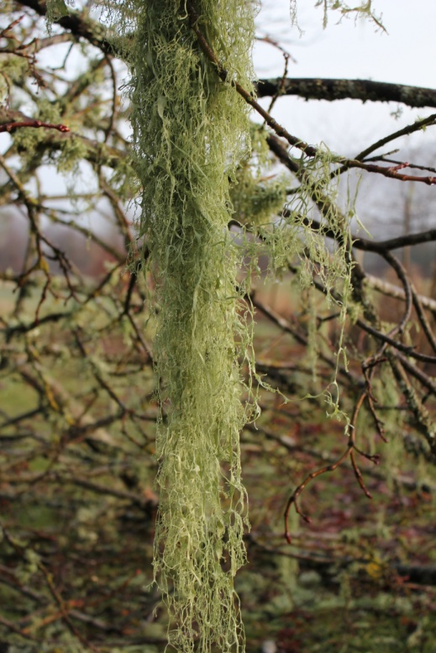
The moss hanging from the giant maple trees on the way to Cowichan Bay is amazing..... spectacular strands hang from the branches.

Today’s Check up Includes:
- Meeting Schedules
- Community meetings and Events
- CDH Site Selection Forums
- The Village – and Potluck Dinner
- Cowichan Adult Learning Centre Open House
- Grandparents Raising Grandchildren support group
- Ottawa Charter for Health Promotion

CCHN Network Member Meetings-
Admin Committee Meeting November 20- CVRD Committee Room 2 – Dinner at 5:30
Membership Committee Meeting November 26, 10 am CVRD
Upcoming Events/ Workshops/ Community Meetings

Community Forums for future Cowichan District Hospital Site Selection
November 30, 10 am to 12 noon, Ladysmith Seniors Hall
November 30, 2:00 pm to 4:00 pm Cowichan Lake Arena Multi Purpose Hall
December 7, 10 am to 12 noon Kerry Park Arena Mill Bay
December 7, 2:00 pm to 4:00 pm Vancouver Island University

The Village Two: Stories of Homelessness, Housing, and Hope
Thursday, November 28, 2013 2:45 TO 5:00 – 5:30 Pot Luck – Community Dinner begins 7:30 – Closing
St John’s Anglican Church Hall 486 Jubilee Street, Duncan

Cowichan Adult Learning Centre Open House
Friday November 22 from 1:00 to 4:00 pm at 756 Castle place. We invite all past, present and future students to visit the school, enjoy some refreshments and door prizes, touch base with old friends and find out about our programs. Please check out our website at www.studycowichan.ca or phone 250-746-0277 for more information.

Grandparents Raising Grandchildren
Grandparents across the province are raising more grandchildren than ever before. The needs of a grandparent are quite different from those of a younger parent or family member. Grandparents Raising Grandchildren offers support, legal advice and more. If you know of a grandparent who could use extra support or information see the attached poster.
Ottawa Charter for Health Promotion
This document seems foundational to the idea of the determinants of health. http://www.who.int/healthpromotion/conferences/previous/ottawa/en/index.html
It might provide some answers to our strategy.

Do you have a resource, event or information you would like to share?
Send it to cindylisecchn@shaw.ca and it will be included in the weekly Check UP Newsletter

