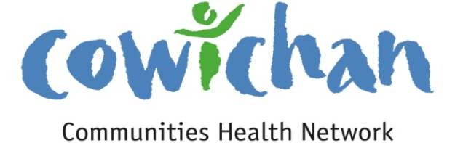

CHECK UP
November 15, 2013
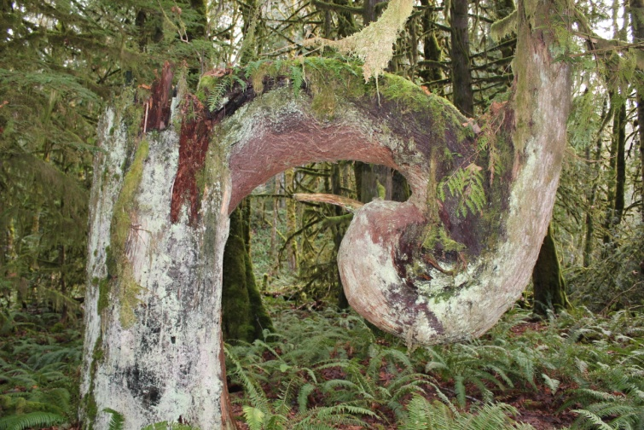
The Glenora Staging area river path has some interesting finds...

Today’s Check up Includes:
- Meeting Schedules
- Community meetings and Events
- Free program for overweight children and families adds sites
- How income inequality hurts every Canadians chance of building a better life
- November 21st National Day of the Child
- Ladysmith Resource Centre has a Blog
- Flu Vaccination Clinics
CCHN Network Member Meetings-
Admin Committee Meeting November 20- CVRD Committee Room 2 – Dinner at 5:30
Membership Committee Meeting November 26, 10 am CVRD Committee Room 1
Upcoming Events/ Workshops/ Community Meetings

Community Forums for future Cowichan District Hospital Site Selection
November 30, 10 am to 12 noon, Ladysmith Seniors Hall
November 30, 2:00 pm to 4:00 pm Cowichan Lake Arena Multi Purpose Hall
December 7, 10 am to 12 noon Kerry Park Arena Mill Bay
December 7, 2:00 pm to 4:00 pm Vancouver Island University

Board Voice Society- Provocative conversation on the kind of future we want to create for our communities
Wed. November 20, Island Savings Centre Mesachi Room 7:00 – 9:00 pm- Cost $10- pre register by November 15 at Volunteer Cowichan

The Village Two: Stories of Homelessness, Housing, and Hope
Thursday, November 28, 2013 2:45 TO 5:00 – 5:30 Pot Luck – Community Dinner begins 7:30 – Closing
St John’s Anglican Church Hall 486 Jubilee Street, Duncan
Free Program for Overweight Children and Families Adds New Sites (First Call)
Run by the Childhood Obesity Foundation, Mind, Exercise, Nutrition ... Do it! (MEND) is registering new participants for January 2014, including eight new provincial sites for a total of 17 locations. Families with a child whose weight is >85th percentile of the BMI for their age and who has no medical limitations for participating in physical activity or group sessions may benefit from MEND. Currently, the MEND program in BC is for children ages 7-13.
Families interested in programs in their area can find more information here
How income inequality hurts every Canadian’s chance of building a better life (First Call)
The Globe and Mail is currently running a Wealth Paradox series, a two-week examination into how the wealth divide is shaping Canada's cities, schools, social programs – and even its national sport.
Using short videos and in-depth articles they highlight how income inequality is affecting Canadians in 4 areas:
- WAGE GAP: Will your pay support a good standard of living and hope for a better life?
- HEALTH CARE: How much will your income determine how healthy you are and how long you live?
- EDUCATION: Will the affluence of your neighbourhood determine the quality of your school?
- RECREATION: Is the middle class getting priced out of Canada’s national pastimes?
Read an overview and watch videos about the 4 themes here
Read in-depth articles about each topic here

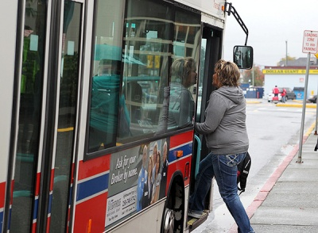
Proposed transit changes back to the drawing board
B.C. Transit says it needs to hear more from users before making any recommendations to change rural transit service in the Cowichan Valley Regional District.

By Ross Armour - Cowichan News Leader Pictorial
Published: November 11, 2013 3:00 PM
Updated: November 12, 2013 6:54 AM
Changes to Cowichan’s rural transit system have been stalled further following a meeting at the end of last month. The public meeting, Oct. 28 at Cowichan Lake Recreation Centre, was put on by B.C. Transit but only 30 people showed up.
“Unfortunately changes are not going to happen that quickly,” said B.C. Transit’s corporate spokesperson Meribeth Burton. B.C. Transit and Cowichan Valley Regional District have been looking at alternatives to the valley’s transit service since July of this year, with particular emphasis on rural communities, including the south end, and the Cowichan Lake area.
“At this time, we need to prepare more recommendations to the CVRD board to be out forward at its December meeting,” said Burton. “We have to go back to broader public consultation as we need more voices to be heard.”
If those pending recommendations are given affirmation by CVRD hierarchy come December, Burton plans to go back to CVRD’s board in the spring with specific changes outlined. CVRD’s elected officials will then vote.
“There’s no point in making changes unless people are happy,” she said. “Because of time commitment, we’re looking for people with the strongest voices of transit as we weren’t expecting a big amount of voices at this time. There needs to be a broader outreach.”
Despite the slow progress, amidst a rallying cry for more input, Burton believes that change is inevitable.
“CVRD and B.C. Transit do think that we could use our buses more regularly. I think there will be change.”
Burton also confirmed a variety of new prospects are being looked into including a Dial-A-Ride service, paratransit service where buses are scheduled on certain days of the week, as well as the use of taxis within the transit system.
November 21st is National Day of the Child-
- Celebrate the children in your world.
- Turn off your cell phone, computer and television!
- Listen, Talk, Read, Sing and Play
- Your children will thank you!
The Ladysmith Resource Centre has a blog
You can visit it at: http://ladysmithresourcescentre.wordpress.com/

Do you have a resource, event or information you would like to share?
Send it to cindylisecchn@shaw.ca and it will be included in the weekly Check UP Newsletter

