



**Health Matters Newsletter**

**August 8, 2014**

**Today’s Health Matters Includes:**

* Meeting Schedules
* Community Meetings and Events
* Our Cowichan Small Grants Available

**Bald Mountain looking over Cowichan Lake- a very doable and relaxing hike.**

C:\Program Files (x86)\Microsoft Office\MEDIA\OFFICE12\Lines\BD14996_.gif

**Our Cowichan- Network Member Meetings-**

* **Next Our Cowichan Network Meeting –September 11,** CVRD Board Room. Light dinner at 5:30 pm – Meeting starts at 6:00 pm
* **Next Admin Committee Meeting-** Wednesday September 17, 5:30 pm CVRD Committee Room 2
* **Next Grant Committee Meeting-** Wednesday October 1, 9 am to 11 am CVRD – Room to be announced

C:\Program Files (x86)\Microsoft Office\MEDIA\OFFICE12\Lines\BD14996_.gif**Upcoming Events/ Workshops/ Community Meetings**

C:\Program Files (x86)\Microsoft Office\MEDIA\OFFICE12\Lines\BD14996_.gif



Calls for Proposals

Cowichan Valley

C:\Program Files (x86)\Microsoft Office\MEDIA\OFFICE12\Lines\BD14800_.gifThank you for your interest in contributing to the health of citizens living in the Cowichan Region. Our Cowichan Communities Health Network (OCCHN) is pleased to provide a maximum grant of $2,000.00 toward eligible projects in the Cowichan Valley. Please read the following information to ensure your proposal meets the funding requirements.

Our Cowichan recognizes the health and well -being of our citizens is impacted by the 12 Key determinants of health within the context of healthy and supportive communities, organizations, families and relationships.

Our Cowichan has the opportunity to make a positive and meaningful contribution to our communities’ future. OCCHN is committed to helping all citizens of the Cowichan Communities enjoy good health.

**Project focus:**

Applications whose priorities for action respond to demonstrated community needs, gaps and priorities and that are evidence based and focus on the determinants of health will be accepted for review.

Application templates are available on our website [www.cchn.ca](http://www.cchn.ca) or contact Cindy Lise at [cindylisecchn@shaw.ca](mailto:cindylisecchn@shaw.ca) . Applications will be accepted up to October 1, 2014. Funding announcements will be made by October 15, 2014 or sooner.

* 1 copy must be submitted by email to: cindylisecchn@shaw.ca
* 1 hard copy must be mailed to:

Our Cowichan

PO Box 20106

Duncan BC,

V9L- 5H1

C:\Program Files (x86)\Microsoft Office\MEDIA\OFFICE12\Lines\BD14996_.gif

C:\Program Files (x86)\Microsoft Office\MEDIA\OFFICE12\Lines\BD14996_.gif

**Family Caregiver Series for family caregivers of people with dementia**

It is being held at **Providence Farm on four Tuesday evenings:  September 9,16,23 and 30 from 6:30 to 8:30.**

**The following topics will be covered:**

                Understanding Dementia

                Creative approaches to Communication

                Responsive Behaviours

                Planning for the future

                Self care for caregivers.

If you wish to register, please call Jane Hope at 1-800-462-2833 or email her at [JHope@alzheimerbc.org](mailto:JHope@alzheimerbc.org)

Jane Hope

Support and Education Coordinator

Alzheimer Society of BC

North and Central Vancouver Island

200 - 1585 Bowen Road

Nanaimo, BC

PHone: 250-734-4170

Toll Free: 1-800-462-2833

Fax: 250-734-4173

Dementia Helpline: 1-800-936-6033

[www.alzheimerbc.org](http://r20.rs6.net/tn.jsp?f=0010TNKWY21OAj6ld-nKHEKYF08EoKS4b9Ha1nGR7O1HaRL6X-DAoy5QnfE6cYdFj9bWMHlRamohxHlIQSLymFxwxzn1P8EYY5XHaC-UHyBjDTFrNmYSxckxCIQtIGJ2YccDOdlwTKBhgjF3XkCOM05lXCsmYRawOJ7siI-WIq7obE=&c=gNXin2BTF9tUeYXllDoGKBRvlMpYtKW32sqMwi69vMmcZC4II6JsQQ==&ch=fRVw-HPQtGWEt4YdWB4PJ3_zMbdoFmVbk1oOYGKpIA3_PFB14HJ9cQ==)

Twitter: @AlzheimerBC | Facebook: AlzheimerBC

Charitable Registration Number: 11878 4891 RR0001

C:\Program Files (x86)\Microsoft Office\MEDIA\OFFICE12\Lines\BD14996_.gif

# Literacy centre about to open

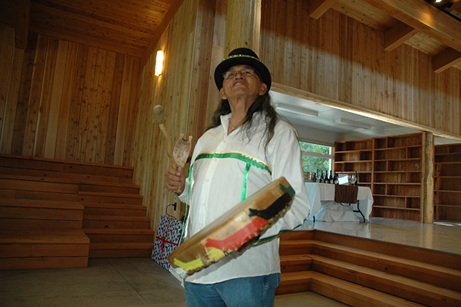

Elder Gene Harry drums during the opening of the Malahat first nation’s Kwunew Kwasun Cultural Resource Centre May 28.

— image credit: Peter W. Rusland

* by  [Kathy Santini - Cowichan News Leader Pictorial](http://www.cowichannewsleader.com/staff_profiles/260943691.html)
* posted Aug 3, 2014 at 2:00 PM

A new centre for the Malahat Nation — a legacy of a program created by former lieutenant-governor Stephen Point and Rotarian Bob Blacker — will open Wednesday, Aug. 6.

During his tenure as LG from 2008 to 2012, Point created the Write to Read program. The purpose of the program is to build ongoing and lasting relationships between British Columbians living in urban environments and First Nations people living in rural, remote, or suburban communities that may not have good educational and employment opportunities. The program’s main focus is on improving Aboriginal literacy.

The 3,000-square-foot building has two main areas and will be used for two primary purposes,  Malahat Nation chief Michael Harry said.

On one side is a replica of a traditional longhouse and on the other, a literacy centre for the band’s children and youths. The facility will also be used for early childhood education programs and be a gathering place.

“This building provides us with the opportunity to learn through reading and education and ties in with the opportunity to learn about our historical ways, which are being passed on to this day,” Harry said.

Write to Read secures donations of books appropriate for school-age children, as well as computers.  As far as the physical facility in which to house those books, Harry said Britco Structures of Langley, which has been a program partner from the beginning, provided first one, then two modular trailers for a library. An architect was hired and 18 months later the Nation is eager to show off its cultural resource facility.

The project cost $650,000, with $150,000 coming from the Malahat Band and another $500,000 in fundraising, and cash contributions.

“This centre allows us to help educate our children and maintain our cultural values and beliefs,” Harry said.

Those interested in attending the grand opening, on Aug. 6 at 2 p.m. at 1 Kwunew Kwasun Lane in Mill Bay should contact Sharon Marshall at sharon.marshall@malahatnation.com.

C:\Program Files (x86)\Microsoft Office\MEDIA\OFFICE12\Lines\BD14996_.gif

Do you have a resource, event or information you would like to share?

Send it to [cindylisecchn@shaw.ca](mailto:cindylisecchn@shaw.ca) and it will be included in the weekly

**Health Matters Newsletter**