

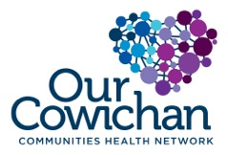

**Health Matters Newsletter**

**August 15, 2014**

**Today’s Health Matters Includes:**

* 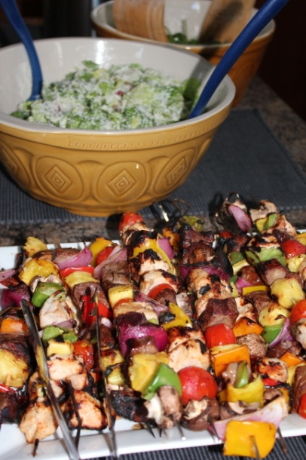Meeting Schedules
* Community Meetings and Events
* Our Cowichan Small Grants Available
* United Way Public Policy Institute

**mmmmm. The taste of summer!**

C:\Program Files (x86)\Microsoft Office\MEDIA\OFFICE12\Lines\BD14996_.gif

**Our Cowichan- Network Member Meetings-**

* **Next Our Cowichan Network Meeting –September 11,** CVRD Board Room. Light dinner at 5:30 pm – Meeting starts at 6:00 pm
* **Next Admin Committee Meeting-** Wednesday September 17, 5:30 pm CVRD Committee Room 2
* **Next Grant Committee Meeting-** Wednesday October 1, 9 am to 11 am CVRD – Room to be announced

C:\Program Files (x86)\Microsoft Office\MEDIA\OFFICE12\Lines\BD14996_.gif**Upcoming Events/ Workshops/ Community Meetings**

**Event**:

**Cowichan Green Community’s 5th Annual Edible Garden & Farm Tour**

**When**: Saturday, August 16th, and Sunday, August 17th, 2014, 10:00AM – 3:00PM

**Where**: Various locations in the Cowichan Region

**Contact**: Alyssa Loucks **Tel**: 250-748-8506 **Email**: [alyssa@cowichangreencommunity.org](mailto:alyssa@cowichangreencommunity.org)

C:\Program Files (x86)\Microsoft Office\MEDIA\OFFICE12\Lines\BD14996_.gif



Calls for Proposals

Cowichan Valley

C:\Program Files (x86)\Microsoft Office\MEDIA\OFFICE12\Lines\BD14800_.gifThank you for your interest in contributing to the health of citizens living in the Cowichan Region. Our Cowichan Communities Health Network (OCCHN) is pleased to provide a maximum grant of $2,000.00 toward eligible projects in the Cowichan Valley. Please read the following information to ensure your proposal meets the funding requirements.

Our Cowichan recognizes the health and well -being of our citizens is impacted by the 12 Key determinants of health within the context of healthy and supportive communities, organizations, families and relationships.

Our Cowichan has the opportunity to make a positive and meaningful contribution to our communities’ future. OCCHN is committed to helping all citizens of the Cowichan Communities enjoy good health.

**Project focus:**

Applications whose priorities for action respond to demonstrated community needs, gaps and priorities and that are evidence based and focus on the determinants of health will be accepted for review.

Application templates are available on our website [www.cchn.ca](http://www.cchn.ca) or contact Cindy Lise at [cindylisecchn@shaw.ca](mailto:cindylisecchn@shaw.ca) . Applications will be accepted up to October 1, 2014. Funding announcements will be made by October 15, 2014 or sooner.

* 1 copy must be submitted by email to: cindylisecchn@shaw.ca
* 1 hard copy must be mailed to:

Our Cowichan

PO Box 20106

Duncan BC,

V9L- 5H1

C:\Program Files (x86)\Microsoft Office\MEDIA\OFFICE12\Lines\BD14996_.gif

**APPLICATION PERIOD IS OPEN FOR THE 2015**

[**UNITED WAY PUBLIC POLICY INSTITUTE**](http://www.uwlm.ca/public-policy-institute)

**Are you a changemaker and want to help strengthen your organization’s capacity to advance social change?** Organizations applying to attend this training program must be from the non-profit sector, active in the areas of social or health-related services and interested in affecting public policy change in those areas. Enrollment is open to organizations from all regions of the province.

This program is specifically designed to help non-profit leaders and their organizations increase their knowledge of the public policy process and their capacity to influence it. Monthly two-day sessions will be delivered over a six month period; from January to June 2015. A dedicated and very experienced cohort, the opportunity for shared learning as part of a small cohort of 25 sector leaders and an applied learning approach with a manageable course calendar make this a unique capacity building opportunity.

United Way starts accepting applications on Aug 13, 2014 and the deadline to apply is Oct 10, 2014. For more information please visit the program webpage at <http://www.uwlm.ca/public-policy-institute>. To obtain an application form, please contact **Yves Trudel** at:

Yves Trudel

Planner, Strategic Priorities, Stronger Communities

[yvest@uwlm.ca](mailto:yvest@uwlm.ca)

- - - - - - - - - - - - - - - - - - - - - - - - - - - - - - -

**United Way** of the Lower Mainland

Change starts here.

- - - - - - - - - - - - - - - - - - - - - - - - - - - - - - -

4543 Canada Way, Burnaby, BC V5G 4T4

P 604.268.1300 ext. 2240

C 778.229.4057

[uwlm.ca](http://www.uwlm.ca/)

C:\Program Files (x86)\Microsoft Office\MEDIA\OFFICE12\Lines\BD14996_.gif

**For Immediate Release: August 7, 2014**

**Event**: **Cowichan Green Community’s 5th Annual Edible Garden & Farm Tour**

**When**: Saturday, August 16th, and Sunday, August 17th, 2014, 10:00AM – 3:00PM

**Where**: Various locations in the Cowichan Region

**Contact**: Alyssa Loucks

**Tel**: 250-748-8506

**Email**: [alyssa@cowichangreencommunity.org](mailto:alyssa@cowichangreencommunity.org)

**Cowichan Green Community’s 5th Annual Edible Garden & Farm Tour – Stories in the Soil**

Story telling can take many forms. Whether it is through a novel, a film, even photography and art, there are many ways to tell a story. Every landscape, every structure, every person; everything has a remarkable story behind it waiting to be revealed. Some of these tales run deep in the soil and present themselves in the very food we eat, and Cowichan Green Community (CGC) invites you to dig up these stories at the 5th annual Edible Garden & Farm Tour.

On Saturday, August 16th, and Sunday, August 17th, from 10am-3pm come hear the history behind some of the most impressive, striking, and tastiest edible gardens and farms the Cowichan Region has to offer. Each day will showcase 5 or more gardens and farms to visit. Attendees are given the chance to meet the very hands behind the shovels, and to take away gardening secrets, tips, and techniques for growing their own food. This self-guided tour will leave you in awe of incredible edible landscapes can form through pure devotion and passion.

“Every gardener and farmer has such inspirational stories to share, and that is the focus of this year’s Edible Garden & Farm Tour which has been expanded to two days,” explains Alyssa Loucks, CGC’s garden tour organizer. “It is important that these stories be told to others, so that the knowledge of growing food can continue to flourish and be passed down to others. These gardens and farms capture the knowledge and creativity of their designers, which will leave everyone inspired to go home and start digging!”

Tickets start at just $15 for members of CGC; $20 for non-members; and $30 for couples. Kids 18 and under are free. For more information or to buy tickets, please contact Alyssa at 250-748-8506, stop by the office at 360 Duncan Street, or email [alyssa@cowichangreencommunity.org](mailto:alyssa@cowichangreencommunity.org)

C:\Program Files (x86)\Microsoft Office\MEDIA\OFFICE12\Lines\BD14996_.gif

Do you have a resource, event or information you would like to share?

Send it to [cindylisecchn@shaw.ca](mailto:cindylisecchn@shaw.ca) and it will be included in the weekly

**Health Matters Newsletter**