



**Health Matters Newsletter**

**May 2, 2014**

**Today’s Health Matters Includes:**

* Meeting Schedules
* Community meetings and Events
* 2011 census data as it relates to early years
* BC Communities Health Atlas- on line maps
* E- Cigarettes- the conversation is growing across the globe
* Gathering of Change Makers

Nature’s Treble Clef ♪

C:\Program Files (x86)\Microsoft Office\MEDIA\OFFICE12\Lines\BD14996_.gif

**Our Cowichan- Network Member Meetings-**

* **Next Our Cowichan Network Meeting –**Thursday May 8, CVRD Board Room. Light dinner at 5:30 pm – Meeting starts at 6:00 pm
* **Next Admin Committee Meeting-** Thursday May 8, 4:30 pm CVRD Board Room ***(Note Change in Date and time)***
* **Next Asset Mapping and Research Committee meeting-** to be announced

C:\Program Files (x86)\Microsoft Office\MEDIA\OFFICE12\Lines\BD14996_.gif

**Upcoming Events/ Workshops/ Community Meetings**

* Gathering Change Makers with Dr Paul Hasselback – May 13 New Life Baptist Church- see advertisement below.

C:\Program Files (x86)\Microsoft Office\MEDIA\OFFICE12\Lines\BD14996_.gif

**2011 Census and National Household Survey Data (Early Years Focus VIA Human Early Learning Partnership)**

2011 Census and National Household Survey Data data has just been posted on the [Human Early Learning Partnership website](http://richmondchildrenfirst.us2.list-manage.com/track/click?u=8da445c2daf2c2a9bca75bcb9&id=cb0033d167&e=8043ea0e33). HELP's census data tables include commonly used socio-economic and demographic variables for HELP Neighbourhoods. In 2001 HELP made use of 19 variables and expanded this list to 82 variables for 2006 and 2011. These variables have been selected for their particular relevance to early child development research, program planning, and policy development.

HELP has purchased many more Census variables than are included in these data tables. Please contact them if you would like to discuss a specific data set that is not included here. There will be a charge associated with preparing unique data requests. If you require census data for other geographies (SD, LHA, HSDA) look at BC Stats [open data](http://richmondchildrenfirst.us2.list-manage.com/track/click?u=8da445c2daf2c2a9bca75bcb9&id=26462ee5c9&e=8043ea0e33).

NOTE: With the 2011 NHS there has been a change in Statscan's data standards. Prior to the 2011 NHS geographic areas with a [global non-response rate](http://richmondchildrenfirst.us2.list-manage.com/track/click?u=8da445c2daf2c2a9bca75bcb9&id=21b9fbd058&e=8043ea0e33) greater than 5% were deemed less reliable, and areas with a rate 25% or greater were suppressed. With the 2011 NHS areas with a GNR greater than 50% are suppressed, and there isn't a flag for less reliable data.

C:\Program Files (x86)\Microsoft Office\MEDIA\OFFICE12\Lines\BD14996_.gif

**BC Communities Health Atlas-**

<http://maps.gov.bc.ca/ess/sv/cha/>

C:\Program Files (x86)\Microsoft Office\MEDIA\OFFICE12\Lines\BD14996_.gif

# E-cigarettes: closing regulatory gaps – (The conversation is taking place across the globe)

Original Text

[The Lancet](http://www.thelancet.com/search/results?fieldName=Authors&searchTerm=%20The%20Lancet)

Many questions about the benefits and harms of e-cigarettes remain unanswered. However, evidence of the aggressive tactics being used by e-cigarette manufacturers to market their products, especially to young people, is increasing. The latest report—[*Gateway to Addiction?*](http://democrats.energycommerce.house.gov/sites/default/files/documents/Report-E-Cigarettes-Youth-Marketing-Gateway-To-Addiction-2014-4-14.pdf)—released last week by a group of Democratic members of the US Congress is based on a survey of nine of the biggest e-cigarette manufacturers. It shows that companies are substantially boosting their advertising budgets, with some doubling expenditure between 2012 and 2013. Six companies sponsored or provided free e-cigarettes at 348 public events in 2012 and 2013, many of them geared towards young people. Most companies manufacture and market a wide variety of flavours such as Cherry Crush, Peach Pit, and Vanilla Dreams that could appeal to youth. Seven companies have television and radio advertisements for their products, some featuring celebrity spokespeople, and some aired during youth-orientated programmes. Companies also use social media to promote their products. And, although none of the companies reported using health benefit or harm reduction claims to market e-cigarettes, the investigation found that some are making misleading claims. Marketing for one brand states: “You get the feeling of smoking real cigarettes without all of their negative side effects.”

Manufacturers have clearly been exploiting the lack of regulatory oversight in the USA and elsewhere. [A 2013 report](http://www.cancerresearchuk.org/sites/default/files/cruk_marketing_of_electronic_cigs_nov_2013.pdf) found similar strategies were being used by companies to attract a youth market in the UK. Widespread unregulated use of e-cigarettes might lead to increased uptake of conventional cigarettes, renormalisation of cigarette smoking, and increases in nicotine addiction and other yet unknown ill health effects.

The US Food and Drug Administration is due to release regulations on e-cigarettes, and the report calls for the agency to act quickly. Other countries and regions have already responded. In March, the European Union issued [regulations](http://europa.eu/rapid/press-release_MEMO-14-134_en.htm) on e-cigarettes including the requirement that they comply with the same advertising and packaging restrictions as regular tobacco products, have mandatory health warnings, and information on addictiveness. The alarming expansion of the e-cigarette market and active targeting of youth should spur other countries to follow suit and urgently regulate e-cigarettes.

C:\Program Files (x86)\Microsoft Office\MEDIA\OFFICE12\Lines\BD14996_.gif

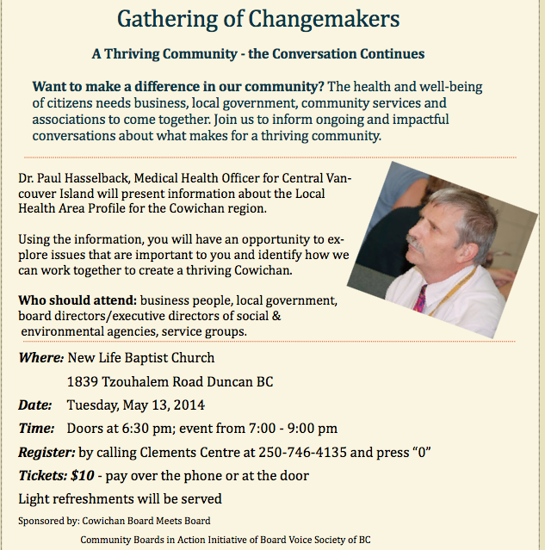

C:\Program Files (x86)\Microsoft Office\MEDIA\OFFICE12\Lines\BD14996_.gif

Do you have a resource, event or information you would like to share?

Send it to [cindylisecchn@shaw.ca](mailto:cindylisecchn@shaw.ca) and it will be included in the weekly Health Matters Newsletter