



**Health Matters Newsletter**

**May 23, 2014**

**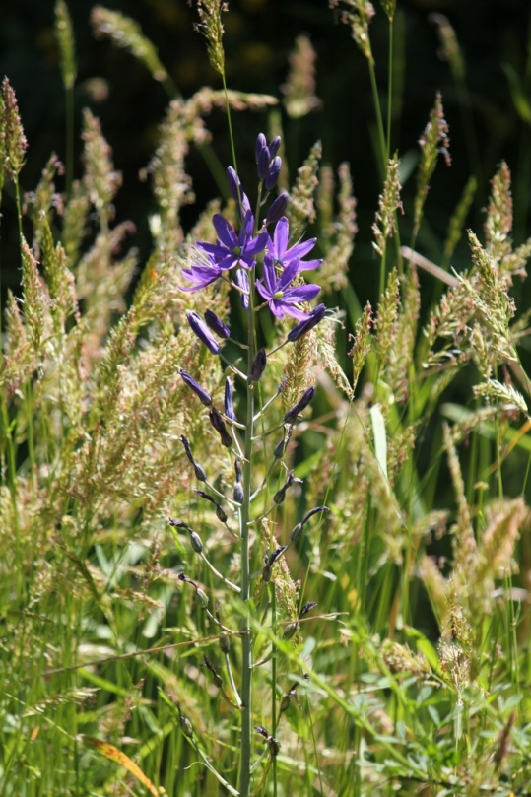Today’s Health Matters Includes:**

* Meeting Schedules
* Community meetings and Events
* Canada Gets a D for Daily Physical Activity

C:\Program Files (x86)\Microsoft Office\MEDIA\OFFICE12\Lines\BD14996_.gif

**Our Cowichan- Network Member Meetings-**

* **Next Asset Mapping and Research Committee meeting-** June 2 -12 pm CVRD Committee Room 2 ***and*** June 9 12 pm CVRD Rooms 213
* **Next Our Cowichan Network Meeting –**Thursday June 12, CVRD Board Room. Light dinner at 5:30 pm – Meeting starts at 6:00 pm
* **Next Admin Committee Meeting-** Wednesday June 18, 5:00 pm CVRD Committee Room 2
* **Next Communications Committee Meeting-** Wednesday June 25, 9:00 am CVRD Room to be announced
* **Next Grant Committee Meeting-** Wednesday October 1, 9 am to 11 am CVRD – Room to be announced

C:\Program Files (x86)\Microsoft Office\MEDIA\OFFICE12\Lines\BD14996_.gif

**Upcoming Events/ Workshops/ Community Meetings**

* Please Note that the draft Communities Profile will be presented at the June 12th meeting- This is a meeting you won’t want to miss!
* Walk of the Nations May 31- Meet at VIU at 9:30 am- Wear Traditional Costumes

**Canada Gets A “D” for Recommended Daily Activity!**

A first-of-its-kind study comparing physical-activity levels of children around the world has found that kids in Canada aren’t anywhere close to achieving the recommended level of daily physical activity despite access to large numbers of parks, playgrounds, hockey rinks and other such facilities.

While 84 per cent of children who are 3 and 4 years old get the recommended 180 minutes of daily physical activity, the picture changes drastically for older age groups. Only seven per cent of kids ages 5 to 11 and a mere four per cent of those aged 12 to 17 get the recommended 60 minutes of daily physical activity of moderate to vigorous intensity.

[**Canadian kids near bottom of international physical activity survey**](http://www.theglobeandmail.com/life/health-and-fitness/physical-activity-levels-of-canadian-kids-lags-behind-global-pack-report-finds/article18754747/?from=18770171)

[](http://www.theglobeandmail.com/life/life-video/video-ctv-toronto-canadian-kids-failing-fitness/article18757518/)

**Video**

[**Video: Are Canadian kids failing when it comes to fitness?**](http://www.theglobeandmail.com/life/life-video/video-ctv-toronto-canadian-kids-failing-fitness/article18757518/)

Active Healthy Kids Canada has put out its annual assessment for ten years, but this year for the first time it compared Canadian children and youth to those in 14 other countries across five continents. Based on nine categories, Canada received a grade of D– in overall physical activity, putting it below Mozambique, New Zealand, Mexico, Kenya, Nigeria and England.

“The global comparisons reveal that Canada, like most other developed countries, receives high grades for physical-activity infrastructures and programs, but trails at the back at the pack for overall physical-activity levels and sedentary behaviours,” Mark Tremblay, chief scientific officer of Active Healthy Kids Canada, said a press conference on Tuesday.

“In short, it seems we’ve built it, but they aren’t coming.”

Access to physical activity in Canada isn’t the problem: 95 per cent of parents report local availability of parks and outdoor spaces; 94 per cent say public facilities such as arenas and pools are available; and over 90 per cent of students have access to a gym or playing fields at school.

But like most other developed countries that have an abundance of infrastructure, including the United States, Australia and Ireland, Canada’s children still fail to get sufficient levels of physical activity. On the other hand, the report found that kids in nations with less access to sports programs and facilities have much more overall activity.

“Paradoxically, it may mean in some ways that less is more,” Dr. Tremblay said.

**THE PROBLEM**

Parents in Canada have effectively outsourced their children’s daily physical activity, said Elio Antunes, president and CEO of ParticipACTION, one of the report’s strategic partners.

“Canadian parents look to structured activities to get their kids moving,” he said. “We have the facilities, we have the playgrounds, we have the arenas, we have the programs. What we’re not doing so well is the spontaneous play aspect. Kids are just not playing within their free time. Their free time is being used primarily with screen time as opposed to active time.”

The report found that 75 per cent of kids aged 5 to 19 participate in organized physical activities or sport. As well, 79 per cent of parents in Canada contribute financially to their kids’ physical activities, whether it is to buy equipment or pay fees.

However, only 37 per cent of parents play actively – often – with their children.

Dr. Tremblay blames a “culture of convenience,” in which parents drive their kids to school because it is easier than having them ride bicycles or walk. Parents will even drive their kids to playgrounds because it takes less time than walking, he said.

As a result, 31 per cent of Canadian kids are overweight or obese, and the number of kids with Type 2 diabetes has been rising for the past two decades.

“A culture of convenience is not associated with optimal health,” Dr. Tremblay said.

**THE SOLUTION**

For Canada to see its overall physical activity grade rise from D– to A+, more than 80 per cent of kids will have to meet the physical-activity guidelines on a daily basis.

That will take years and would require a fundamental cultural change, Dr. Tremblay said.

Jennifer Cowie Bonne, CEO of Active Healthy Kids Canada, suggests two key solutions to begin to bring about that change.

The first is to make it easier for kids to use active transportation to get to school – walking and cycling instead of going by car or using transit.

According to the report, 62 per cent of parents said their kids aged 5 to 17 are always driven to and from school, whether by car, bus, or other form of transit.

“Lower and better enforced speed limits, traffic-calming measures and crossing guards along school routes are all measures that can improve safety to help parents allow their children to walk, wheel and cycle more,” she said.

The second is for school boards and municipalities “to revisit policies, bylaws and playground rules that restrict opportunities for active outdoor play, such as no balls in the school yard or no street hockey,” she said.

Dr. Tremblay offered one very simple solution for families: “Get outside and play.”

**ACTIVITY BREAKDOWN**

**RUNNING**

**75** Percentage of Canadian 5- to 19-year-olds who participated in physical activity and sport during the previous year, according to parents

**34** Percentage of kids who are 5 to 17 who participate in physical activity four or more times per week

**50** Percentage who participate two to three times per week

**48** Percentage of boys 15 to 19 who participate in organized physical activities and sports after school

**30** Percentage of girls in the same age group who do

**WALKING**

**25** Percentage of Canadians aged 12-19 who report walking less than one hour weekly to get to and from school and to run errands

**13,097** The average number of steps daily by kids aged 5 to 19 in Nunavut

**10,688** The average number in Newfoundland

**1.6 kilometres** The socially acceptable walking distance to school in Canada. Distance between home and school is the single most reported reason why children don’t walk or bike to school.

**SITTING**

**5.8** The number of hours a day Canadian kids aged 3 to 4 spend being sedentary

**7.6** The number of hours a day for 5- to 11-year-olds

**9.3** The number of hours a day for 12- to 17-year-olds

**66** Percentage of Canadian parents who think their kids spend too much time watching TV or using a computer

**OTHER COUNTRIES**

**Finland: D** It may have scored low in overall physical activity but Finland had the highest grade in active transportation: Nearly all children walk or cycle to school if they live less than one kilometre away, while 74 per cent of kids who live between one and three kilometres do.

**New Zealand: B** A high grade, but the country also found an interesting side-effect to more active play. Four elementary schools reported that when playground rules such as “no ball areas” and “don’t run here” were relaxed, school administrators reported a drop in bullying, injuries and vandalism.

**Mozambique: B** “Physical activity behaviours … are positively influenced by the rural environment and the absence” of motorized transport, according to the report.

**Mexico: C+** Fifty-nine per cent of Mexican youth are classified as active.

**Kenya: C** Eighty-seven per cent of rural and 42 per cent of urban children use active transport to get to and from school.

**Nigeria: C** Forty-seven per cent of kids ages 5 to 18 participate in moderate to vigorous physical activity for three or more days in a week.

**England: D+** Thirty-three per cent of boys and 21 per cent of girls meet the U.K.’s physical-activity guidelines, which recommend one hour of moderate to vigorous activity per day.

**Colombia: D** Twenty-six per cent of 13- to 17-year-olds meet the World Health Organization’s physical-activity guidelines.

**Ghana: D** Twenty-one per cent of kids who attend school are sedentary, and that does not include time spent sitting in school.

**South Africa: D** Almost half of children get less than 60 minutes per day of moderate physical activity.

**Australia: D–** Twenty per cent of kids 5 to 17 years old get the recommended 60 minutes of moderate to vigorous intensity physical activity.

**Ireland: D–** The report says 11 per cent to 43 per cent of kids meet the physical activity guidelines, but did not offer a breakdown.

**United States: D–** Only 12.7 per cent of children travel to school by active means such as walking or biking.

**Scotland: F** Among kids 11 to 15 years old, only 19 per cent of boys and 11 per cent of girls get the recommended 60 minutes of moderate to vigorous physical activity per day.

Follow Dave McGinn on Twitter: [@Dave\_McGinn](http://twitter.com/#!/@Dave_McGinn)

C:\Program Files (x86)\Microsoft Office\MEDIA\OFFICE12\Lines\BD14996_.gif

Do you have a resource, event or information you would like to share?

Send it to [cindylisecchn@shaw.ca](mailto:cindylisecchn@shaw.ca) and it will be included in the weekly Health Matters Newsletter