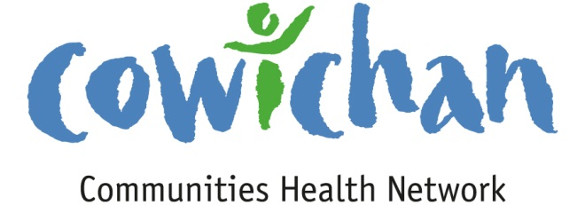

CHECK UP
June 28, 2013

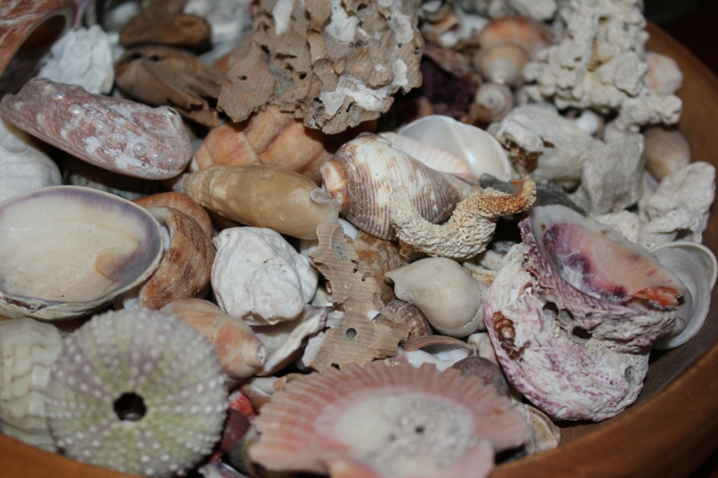
Seashells and summer go together like peanut butter and jam!

Today’s Check up Includes:
- Meeting Schedules
- Community meetings and events
- Health Council of Canada Progress Report 2013
- First Nations Council Health Hubs and You Tube Video including our own Hul’qumi’num Health Hub
- Youth jobless rate over twice adult rate in Canada
CCHN Network Member Meetings-
Asset Mapping and Research Committee Meeting -June 28th 12:00 pm Committee Room 1
Strategic Planning Session (CCHN members only) Wednesday July 17, 4:00 pm to 8:00 pm –Taiji Group-
1145 Maple Bay Road (Dinner Provided)
Upcoming Events/ Workshops/ Community Meetings
- July 1st in Ladysmith- pdf attached to email- Tons of fun at Transfer Beach
- July 1st in Honeymoon Bay-

Health Council of Canada- Progress Report-
Progress Report 2013: Health care renewal in Canada May 2013 Download full report - See more at: http://www.healthcouncilcanada.ca/rpt_det.php?id=481#sthash.Dd7bQg7N.dpuf

First Nations Health Council- Community Engagement Hubs. (From First Nations Council Website)

HUB: Helping Us Build Documentary
Learn how Community Engagement Hubs bring grassroots voices into the implementation of the Tripartite First Nations Health Plan and how they work with First Nations communities to help determine and achieve their own health priorities.
This 26-minute video follows the stories of five very distinct Community Engagement Hubs, watch how this collaborative process creates the strength needed to overcome challenges and build towards healthier First Nations children, families, and communities.
http://www.youtube.com/watch?feature=player_embedded&v=fsbABc9QoQY

What are Community Engagement Hubs?
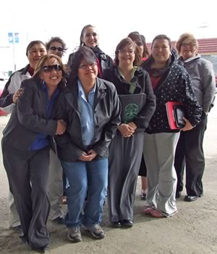
Community Engagement Hubs (CeH’s) are groups of First Nations communities who agree to plan, collaborate, and communicate to meet their nation’s health priorities. CeH’s also provide a vehicle for First Nations Communities to partner with the First Nations Health Council to implement the Tripartite First Nations Health Plan. CeH’s are collaborations between First Nations communities working through one agreed upon organization. The formation of CeH’s encourages natural collaborations based on tribal and geographical factors, and provides resources to existing capacity.
There are currently 32 community hubs representing 175 First Nations. Hub host agencies and the communities affiliated with each hub are as follows:

Vancouver Island Region Hubs
- Nuu-chah-nulth Tribal Council (NTC) Ahousaht First Nation, Ditidaht First Nation, Ehattesaht, Hesquiaht First Nation, Hupacasath First Nation, Huu-ay-aht First Nation, Ka:’yu:’k’t’h’/Che:k’tles7et’h’, Mowachaht/Muchalaht, Nuchatlaht, Tla-o-qui-aht First Nation, Toquaht, Tseshaht First Nation, Uchucklesaht First Nation, Ucluelet First Nation
- Inter Tribal Health Authority (ITHA): Namgis, Nanaoose, Qualicum, Snuneymuxw, Songhees, T’Sou-ke, Gwawaenuk, Kwicksutaineuk/Ah-Kwa-mish, Tsawataineuk [Kingcome], Beecher Bay, Esquimalt, Homalco, Tseycum
- Kwakiutl District Council (KDC): Da’naxda’xw, K’omoks, Kwakiutl, Kwiakah, Mamalilikula-Que’Qua’Sot’Em, Wei Wai Kai [Cape Mudge], Wei Wai Kum [Campbell River], Gwa’Sala’Nakwaxda’xw, Quatsino, Tlatlasiwala
- Cowichan (Hulquminum) Cowichan Tribes, Lake Cowichan, Lyackson First Nation, Malahat First Nation, Penelakut, Halalt, Chemainus
- South Island: Tsartlip, Tsawout

Vancouver Coastal Region Hubs
- Central Coast Hub: Heiltsuk, Nuxalk, Wuikinuxw [Oweekeno], Kitasoo. Hub Coordinator: Pamela Reid ( tagilaconsulting@yahoo.ca)
- Squamish/Tsleil-Waututh Nations: Tsleil-Waututh Nation, Squamish Nation. Hub Contact: Kim Brooks ( kim_brooks@squamish.net)
- Sunshine Coast Hub: Tla’amin, Sechelt. Hub Contact: pending.
- Lower Stl’Atl’Imx Tribal Council: Douglas, N’Quatqua, Samahquam, Skatin, Lil’wat/Mt. Currie. Hub Coordinator: Joyce Schneider ( joyce.schneider@lstc.ca)

Interior Region Hubs
- Williams Lake and West Region (Tsilhqotin National Government): Tsi Del Del [Alexis Creek], Tl’esqox-t’in [Toosey Indian Band], Xeni Gwet’in First Nation Gov. [Nemiah Valley], ?Esdilagh [Alexandria], Yunesit’in Government [Stone]
- Northern St’at’imc Health Hub(Lillooet Tribal Council): T’it’q’et [Lillooet], Seton Lake, Xaxli’p [Fountain], Bridge River, Cayoose Creek
- Thompson Region (Fraser Canyon Tribal Administration): Skuppah Indian Band, Lytton First Nation, Nicomen Indian Band
- Merritt area (Scw’exmx Community Health Services Society):Coldwater Indian Band, Nooaitch, Shackan, Cooks Ferry, Siska
- Okanagan (Okanagan Nation Alliance)Osoyoos Indian Band, Penticton Indian Band, Upper Nicola Indian Band, Lower Similkameen Indian Band, Upper Similkameen Indian Band, Westbank First Nation, Okanagan Indian Band. Urban partners include: Okanagan Aboriginal Aids Society, Ooknakane Friendship Centre – Penticton, First Nations Friendship Centre – Vernon, Ki-Low-Na Friendship Society – Kelowna, Lower Columbia All First Nations - Castlegar
- Secwepemc area (Q’wemtsin Health Society):Kamloops Indian Band, Skeetchestn, Whispering Pines/Clinton, Canoe Creek/Dog Creek, Soda Creek, Williams Lake, Adams Lake, Little Shuswap, Splatsin First Nation, Simpcw First Nation, Canim Lake, Neskonlith, Esketemc [Alkali], Bonaparte, Ts’kw’aylaxw First Nation [Pavillion]
- Ktunaxa Nation Hub:Akisq’nuk First Nation [Columbia Lake], Tobacco Plains Indian Band, Lower Kootenay Indian Band, St. Mary’s Indian Band

Fraser Region Hubs
- Sto:lo Nation:Aitchelitz, Leq’á:mel, Matsqui, Popkum, Skawahlook, Skowkale, Shxwhà:y Village, Squiala, Sumas, Tzeachten, Yakweakwioose
- Seabird Island (Ye mi sqeqo:tel la xwe’lets emo:t o): Seabird Island First Nation, Scowlitz, Soowahlie, Kwaw’Kwaw’Apilt, Kwantlen, Shxw’ow’hamel, Chawathil, Cheam, Union Bar, Chehalis, Skwah
- Fraser Canyon (Fraser Thompson Indian Services Society):Boston Bar, Boothroyd, Spuzzum, Oregon Jack Creek. [*Please note that the FTISS hub communities receive services from both the Fraser and Interior health authority’s.]

Northern Region Hubs
- Haida Health Hub: Old Massett Village Council, Skidegate Band
- Carrier Sekani Family Services:Burns Lake Band [Ts’il Kaz Koh], Takla Lake First Nation, Stellat’en First Nation, Cheslatta Carrier Nation, Nee-Tahi-Buhn Band, Skin Tyee First Nation, Yekooche, Wet’suwet’en First Nation
- Talhtan Health:Iskut, Tahltan Band Council [Dease Lake & Telegraph Creek]
- Finlay: Kwadacha First Nation, Tsay Keh Dene First Nation
- Treaty 8:Halfway River First Nation, Doig River First Nation, West Moberly Lake First Nation, Prophet River Band [Dene Tsaa Tse K’Nai First Nation], Saulteau First Nation
- Northwest Health Hub: Gitanmaax, Gitanyow, Gitsegukla, Glen Vowell, [Sik-e-Dakh] Band, Kispiox, Hagwilget Village, Gitwangak, Moricetown [Wet’suwet’en]
- Dakelh’ne Hub: Nak’azdli Band, Nadleh Whuten First Nation, Saik’uz First Nation, Tl’azt’en First Nation, Lheidli T’enneh First Nation
- North Coast Tsimshian: Hartley Bay, Metlakatla Indian Band, Lax’Kw’alaams First Nation
- Coast Mountain Alliance: Kitsumkalum Indian Band, Kitselas Indian Band, Haisla First Nation
- Nisga’a Valley Health Society:1. Gingolx, Laxgalts’ap, Gitwinksihlkw, Gitlaxt’aamiks, Gitmaxmak’ay Nisga’a Pr Rupert/Pt. Edward Society, Gitlaxdax Terrace Society, Nisga’a Ts’amiks Vancouver Society
- True North Hub: Dayla Dene Council [Lower Post], Taku River Tlinglit First Nation, Good Hope Lake

Why Hubs?
Collaboration and joint planning create efficiencies, and will provide better health services for BC First Nations people. For example, where it may not be feasible to have a mental health expert in every community, the hub concept would allow for planning to have one expert available to serve the member communities of the hub. In this way, collaboration and resource sharing between the nations in a hub can fill health gaps that otherwise would not be addressed.
Hubs also act as a communications vehicle, allowing the Health Council to effectively communicate in a accurate and timely manner with all 203 BC First Nations. Currently, there are 29 community engagement hubs, representing 161 First Nations in various stages of development.
Youth jobless rate over twice adult rate in Canada (from First Call BC)
Stats Canada has released a new study “Unemployment Dynamics Among Canada’s Youth”
Highlights from the study include: “The youth unemployment rate has historically been higher than that for adults. (…) In 2012, the unemployment rate of youths aged 15 to 24 was 14.3%, compared with a rate of 6.0% for workers aged 25 to 54 and workers aged 55 or older. The gap between the unemployment rates of youths and adults has not decreased since the early 1990s, and has even increased slightly since 2010. In 2012, the youth unemployment rate was 2.4 times that of workers aged 25 to 54, the biggest gap recorded since 1977. Youth are twice as likely as adults to be laid off: The majority of youth (60.4% in 2012) who were employed one month and unemployed the next month made this transition because they were laid off. (…) Young workers are more likely than adult workers to be laid off by their employers. The monthly layoff rate among youth was 3.5% in 2012. This rate is more than twice the rate of 1.3% for workers aged 25 to 54 and the rate of 1.5% for workers aged 55 or older (Chart 5). Since 1977, the annual layoff rate for youth aged 15 to 24 has been between 2.0 to 2.7 times that of workers aged 25 to 54.”
You can read the full study here
Read the Globe and Mail article about the study Gap between youth, adult jobless rates biggest since 1977: Statscan

Do you have a resource, event or information you would like to share?
Send it to cindylisecchn@shaw.ca and it will be included in the weekly
Check UP Newsletter

