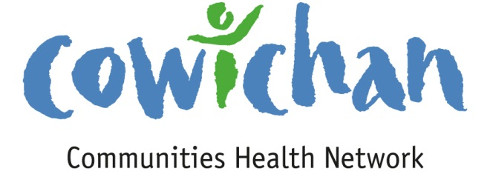

CHECK UP
July 5th, 2013

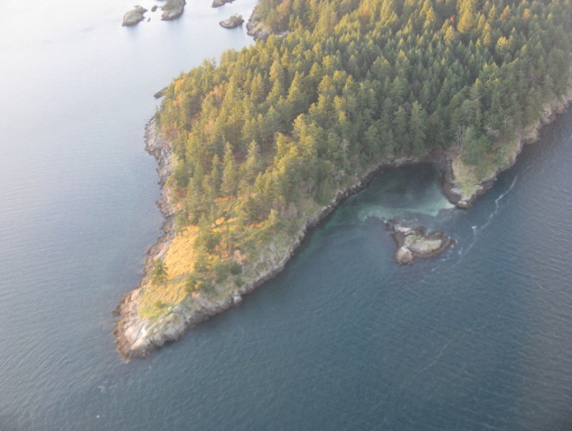
If you ever get the opportunity to take a sea plane flight to Vancouver you must jump at the chance... the world that we know so well from down below is even more spectacular from the air!

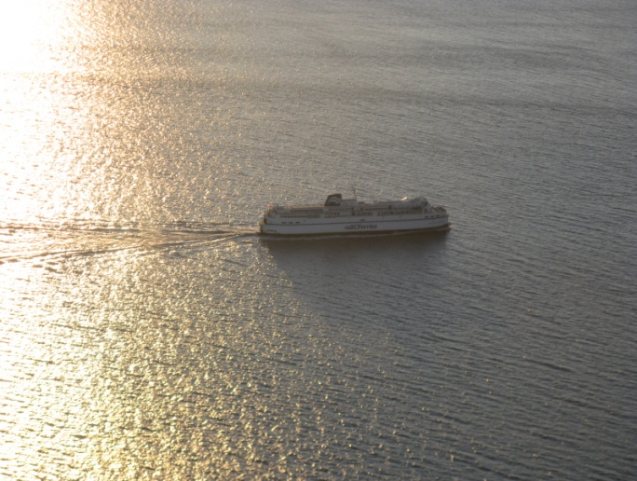

Today’s Check up Includes:
- Meeting Schedules
- Community meetings and events
- Parent Child Mother Goose Training
- Research Invitation for adults living with dementia in rural locations

On a sad note... The Cowichan Valley lost a precious child due to drowning this week... PLEASE take every precaution around the water this summer.... One child is too many
CCHN Network Member Meetings-
Strategic Planning Session (CCHN members only) Wednesday July 17, 4:00 pm to 8:00 pm –Taiji Group-
1145 Maple Bay Road (Dinner Provided)
Upcoming Events/ Workshops/ Community Meetings
- Cowichan Lake Primary Health Care Conversation- July 10th 6- 8 pm Cowichan Lake Sports Arena- Everyone Welcome
- Crofton Movies In The Park- July 6th, July 20th, August 10th, August 24th, September 7th – 9:00 pm Crofton Old School Museum Park by the Saltspring Ferry- Its back! The fun free summertime event for families of all ages... Movies in the Park will feature a selection of family friendly films like Indiana Jones, How to Train your dragon and We Bought a Zoo. For a full list see our poster. Every second Saturday starting the end of June until the first week of September. No cost, by donation with proceeds going to a new Skate park for Crofton. Concession available. Start time is approx 9pm for all showings (dusk). Bring a blanket or something comfy to sit on and enjoy!

- Ladysmith Resources Centre Concerts in the Park- July 7, July 14, July 21, July 28, August 11, August 18, August 25th – 6:00 pm in the Amphitheatre at Transfer Beach Concerts in the Park! Volunteer driven and at the Amphitheatre at Transfer Beach Park. Performers are enlisted for eight – 2 hour Sunday evening concerts. People enjoy an evening of song, while watching boats sail by, seals playing near the shore, and enjoying the early evening breezes off the ocean while having their picnic dinner
Parent-Child Mother Goose (PCMG) Training
This training is being funded through
Cowichan Valley Mother Goose Community Collaborative & Cowichan Success by 6

When: Fri. & Sat. September 13 & 14, 2013 Venue: Crofton Community School
Cost: Free in exchange for a commitment of facilitating 3 programs over a 2 year period in the Cowichan Valley or $200.00 fee for those not planning to facilitate these programs as stated above.
For details including application form contact:
Bonnie Potter, VIHA (250)709-3050 Email: Bonnie.Potter@viha.ca
or Wendy Lambert 250-246-3588 Email: ccsa@sd#79.bc.ca
Research Invitation

Understanding emergency department safe care transitions for older adults with dementia living in rural communities
An invitation to participate in our research project

Researchers from the University of Alberta, Vancouver Island Health Authority and Covenant Health Rural Services in Alberta are conducting a study looking at how the emergency department can become more elder-friendly for people living with dementia and their caregivers. The researchers are looking for:

- adults with mild to moderate dementia, over age 65
- living at home in the community
- who have visited the Cowichan District Hospital in Duncan with their family caregiver within the last 12 months

Please consider participating in a one hour interview. Older adults with dementia and their caregivers will be interviewed together. If you would like to learn more about this study, please contact:

Dr. Belinda Parke
Vancouver Island Health Authority
Phone number: (Nanaimo) 250 740 6971

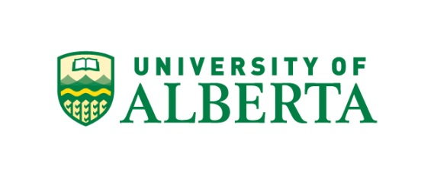

Do you have a resource, event or information you would like to share?
Send it to cindylisecchn@shaw.ca and it will be included in the weekly
Check UP Newsletter

