

**Health Matters**

**January 24, 2014**

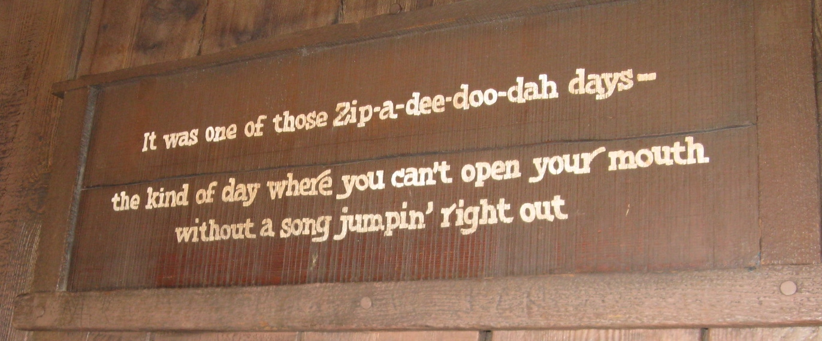

**Sometimes Disneyland just finds its way back into my thoughts.... Have a zip-a-dee-doo-dah-day!**

**Today’s Check up Includes:**

* Meeting Schedules
* Community meetings and Events
* Healthy Eating for Better Mental Health and Wellbeing webinar
* Invitation to participate in MCFD focus group
* Buy Local Buy Fresh – Cowichan Food Map

C:\Program Files (x86)\Microsoft Office\MEDIA\OFFICE12\Lines\BD14996_.gif

**CCHN Network Member Meetings-**

* **Communications Committee Meeting** – Friday January 24, 9:00 am 1145 Maple Bay Road- Taiji Studio
* **Asset Mapping and Research Committee Meeting** – January 30, 1:00 pm CVRD Committee Room 2
* **Grant Committee Meeting**- February 6, 10 am CVRD Committee Room 1
* **Next Our Cowichan Network meeting – Thursday February 13, 6:00 pm** CVRD Board Room- light dinner served at 5:30
* **Next Admin Committee Meeting** Wednesday February 19, 5:30 pm CVRD Committee Room 2

C:\Program Files (x86)\Microsoft Office\MEDIA\OFFICE12\Lines\BD14996_.gif

**Upcoming Events/ Workshops/ Community Meetings**

* **See attached invitation to learn more about the Cowichan Valley Early Childhood Development scores.**

C:\Program Files (x86)\Microsoft Office\MEDIA\OFFICE12\Lines\BD14996_.gif

## [Healthy Eating for Better Mental Wellbeing](http://learningcircle.ubc.ca/2014/01/healthy-eating-for-better-mental-wellbeing-2/)

[](http://learningcircle.ubc.ca/files/2013/03/FNHA-Logo.jpeg)Healthful eating and having a positive relationship with food is about so much more than nutrient content. Our eating habits are shaped by many different internal personal and cultural factors and external societal factors. Join Registered Dietitian **Rebecca Sovdi** (First Nations Health Authority) for a chat about how food and food enjoyment in a society with so many different food choices can impact our mental well-being.

All are welcome to attend and participate in this FREE live videoconference and computer webinar session.

**Date**: Thursday, February 6, 2014

**Time**: 10 a.m. to 12 p.m.

**Where**: Participate live via videoconference **OR** computer webinar. Want to know the difference between videoconference and computer webinar? Click [***here***](http://learningcircle.ubc.ca/2013/04/whats-the-difference-between-videoconference-and-webinar/) to find out.

**Registration**: Click [here](http://learningcircle.ubc.ca/about/session-registration-form/) to register. Pre-registration is required to attend this free live event.

**Learning Objectives**

At the end of the session participants will be able to:

* Identify societal and personal factors that shape eating habits
* Reflect on how eating habits can positively or negatively impact mood and mental health
* Identify how healthy eating can set a good foundation for children’s mental health
* Discuss healthy eating as a component of treatment for individuals living with mental health challenges and/or addictions

**About the Presenter**

**[](http://learningcircle.ubc.ca/files/2013/09/Rebecca-Sovdi.jpeg)Rebecca Sovdi** is a Registered Dietitian and has worked in First Nations health for seven years. She completed her bachelor’s degree at the University of Saskatchewan and a Masters in Public Health at the University of Waterloo. She is passionate about promoting health through a wellness lens that helps others find balance and enjoyment in life. Rebecca grew up in a small town in southern Saskatchewan and now enjoys living as a visitor on traditional Coast Salish territory.

## PowerPoint Presentation Now Available

[Click here](http://learningcircle.ubc.ca/files/2013/09/Nutrition-and-Your-Mental-Health.pdf) to download a PDF version of the PowerPoint presentation that was shown at last year’s session.

**C:\Program Files (x86)\Microsoft Office\MEDIA\OFFICE12\Lines\BD14996_.gif**

**Island Health and the Ministry of Child and**

**Family Development**

**NEED YOUR INPUT!**

***YOU ARE INVITED*** *to participate in a* ***FOCUS GROUP*** *to help improve mental health and substance use services for children, youth and families*

*in the Vancouver Island region.*

The Ministry of Child and Family Development (MCFD) and Island Health are working together to strengthen and improve child, youth and family mental health and substance use services on Vancouver Island. They are in the process of creating a three year service plan with extensive participation from key stakeholders including service users like you!

**Come have your voice heard!**

**WHAT:**

Five focus groups will be held in South and Central Vancouver Island to gather information for a three year service plan between MCFD and Island Health. Each group will have 6-12 participants and will be led by a trained facilitator. You will have an opportunity to have your perspective heard, but are not required to share any personal experience. Any travel, and/or parking expenses will be covered. Snacks and beverages will be available.

**WHO:**

We are inviting participants from South and Central Island who fit within any one of these groups:

- Youth (aged 15-24) who have experienced mental health issues

- Parents/caregivers of children/youth who have experienced mental health issues

- Parents/caregivers of youth are or have been substance users

- Parent/caregivers of youth with developmental delays and mental health and/or substance use issues

**WHEN:**

*Parent/ Caregivers Focus Groups:*

February 11th and 12th (South Island); 6:00pm-8:00pm

February 13th and 17th (Central Island); 6:00pm-8:00pm

*Youth Focus Group:*

February 17th (South Island location); 4:00pm-6:00pm

**WHERE:** Convenient locations in Nanaimo (Central Island) and Victoria (South Island) area.

**HOW:** Contact Larissa by e-mail or phone for more information and to get involved:

**Larissa Coser**

E-mail: lcoser@impactbc.ca Phone: 250-327-8278

C:\Program Files (x86)\Microsoft Office\MEDIA\OFFICE12\Lines\BD14996_.gif

**2014 Buy Local! Buy Fresh! Cowichan Food Map - Register today!**  
  
Farm registration for the [2014 Buy Local! Buy Fresh! Cowichan Food Map](http://cowichangreencommunity.us5.list-manage.com/track/click?u=3fc195bd2f854daf25b3ee562&id=2137467a16&e=1a916f2779) is now open.    
  
A direct marketing tool for farms in the Cowichan Region, this map is published annually in June by the Cowichan Green Community (CGC). The goal of the map is make food producers more visible in the region, to support their growth into the market, and to link consumers to local food. The map showcases our region's abundance of local farms, food producers, and local food events.   
  
To get your farm on the map, [register online](http://cowichangreencommunity.us5.list-manage1.com/track/click?u=3fc195bd2f854daf25b3ee562&id=45f7b0dfe5&e=1a916f2779) or stop by our office (360 Duncan Street) to pick-up a paper application. Applications will be accepted until March 15, 2014.   
  
For more information, or to learn how to place an ad on the map, please contact Raelynn at [raelynn@cowichangreencommunity.org](mailto:raelynn@cowichangreencommunity.org).  

C:\Program Files (x86)\Microsoft Office\MEDIA\OFFICE12\Lines\BD14996_.gif

Do you have a resource, event or information you would like to share?

Send it to [cindylisecchn@shaw.ca](mailto:cindylisecchn@shaw.ca) and it will be included in the weekly Health Matters Newsletter