CHECK UP
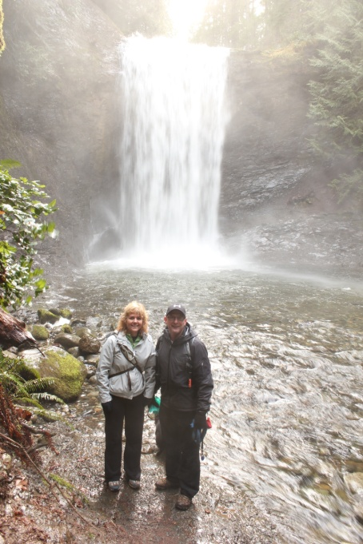
February 8, 2013

Hello Everyone,
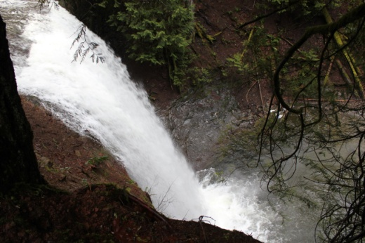
This is not in the Cowichan Region but it is close. The Ammonite Falls off of Jingle Pot Road in Nanaimo are over the top spectacular, especially at this time of year with the increased volume of water. Getting down to the river from the hillside is a challenge and you will need to use the rope provided but once you get to the water you can actually find fossils!

Meetings

Asset Mapping and Research Committee- February 14, 4:30 pm CVRD- Cindy, Jan, Anita, Carol, Linden
CCNH- February 14, 5:30 pm light dinner 6:00 pm Meeting CVRD Board Room – All
Admin Committee February 20, 5:30 pm Committee Room 2

Upcoming Events/ Workshops/ Community Meetings

- Sundrops Centre for Child Development Advisory Committee (NEW) 3:30 PM Wed February 13, 2013 at 5856 Clements Street, See information below re: request for new members
- Blood Donor Clinic Shawnigan Lake BLOOD DONORS NEEDED
May 16 2012, May 17 2012, July 11 2012, July 12 2012, September 5 2012, September 6 2012, February 20 2013, February 21 2013
10:00 am
Mill Bay Community League Hall
Canadian Blood services are holding a blood donor clinic Wednesday (10:15- 5:45pm), Thursday (10:15- 5:45pm) in the Mill Bay Community League Hall
Canadian Blood Services is in need of more blood donors, Please consider donating an hour of your time to save three lives.
To book an appointment to donate blood call 1-888-2-DONATE or go online www.bloodservices.ca

- Blood Donor Clinic in Duncan DONORS NEEDED
February 26 2013, February 27 2013, February 28 2013
1:00 pm
Island Saving Centre Duncan
Canadian Blood services are holding a blood donor clinics Tuesday (1:15pm – 7:15pm), Wednesday (1:15pm – 7:15pm) and Thursday (12- 6pm) in the Island Saving Centre Duncan
Canadian Blood Services is in need of more blood donors, Please consider donating an hour of your time to save three lives.
To book an appointment to donate blood call 1-888-2-DONATE or go online www.bloodservices.ca

- Free Adaptive Fitness Classes Frank Jameson Community Centre Ladysmith
Last Friday of Every Month, 11:00 a.m. - 12:00 p.m.
If you have arthritis or other mobility limitations these aquatic exercise classes may be just for you. Let our qualified staff help you take advantage of the water’s properties to attain and maintain fitness levels without stress to muscles and joints.

Effective January 1, 2013: The City of Duncan will offer a full rebate on monthly transit passes
purchased by City of Duncan residents. The program will run until March 31, 2013 funds permitting. To Obtain a Rebate ,City residents will purchase monthly transit passes at normal outlets, then apply for a refund. Residents will be asked to fill out a short application form, provide proof of residency, and submit a copy of the receipt from the purchase of their transit pass. The City will send a rebate cheque for qualifying purchases to the applicant. Application forms are available online at www.duncan.ca under City Hall - Forms & Applications, or in person at City Hall, the CVRD, and the Island Savings Centre. Mail or drop off your application to: City of Duncan - 200 Craig Street Duncan, B.C. V9L-1W

Communities Collaborating Institute 2013
The Communities Collaborating Institute (CCI) is Tamarack's signature week-long learning event. This event provides a unique opportunity to join a dynamic learning community of practitioners from across Canada and beyond who are committed to deepening their capacity to lead community collaborations. This year's event will be held in Edmonton, AB, Oct. 7-11, 2013. Registration will be available soon so sign up through the link below to receive e-mail updates about this much-anticipated annual learning event!
Sign up for CCI e-mail update here
Results from EDI on Physical Health and Well-being
Has your community been particularly concerned with its vulnerability rates on the Physical Health and Well-Being scale?
If so, we will be holding a teleconference on Wednesday, February 27th from 3:15-4:30 in order to facilitate sharing between communities who have put in place initiatives addressing this area of vulnerability and others who are looking to do something about it.

If you are interested in attending, please let me know by February 8th. samantha.berger@ubc.ca

Best,
Samantha

Open Letter

Invitation to our Annual Gathering of Aboriginal Men

Standing up against Violence towards Aboriginal Women and Children

On Friday, February 15th, from 9:00 am to 12:00 pm, a group of Aboriginal men will meet at the Harbour Towers Hotel in Victoria to stand up for Aboriginal women and children and to speak out against all forms of violence towards them. There is no fee, and coffee and snacks will be provided.

This letter is both a call to action and an open invitation for our brothers, uncles, fathers, grandfathers, and sons to come together and continue our Province-wide campaign to end violence against Aboriginal women and children.

Aboriginal women are three times more likely to experience domestic violence than non-Aboriginal women, and three times more likely than non-Aboriginal women to be killed by someone they know. Too many of our wives, daughters, sisters, aunties, mothers, grandmothers are not safe in their own home. Too many have been murdered or are missing. It is time for us to change this.

This cycle of violence came from residential schools, racism against our Peoples, and colonization. It was never in our culture to do violence to the women and children in our families and communities, it was always our responsibility to protect them.

Many efforts, projects, and strategies are now under-way throughout the province to change this reality, but we can and need to do more. Silence is not good enough, and simply being a non-abuser is not good enough. We need to speak up and take action, and we need to support each other as Aboriginal men.

The Gathering of Aboriginal Men - Standing up against Violence towards Aboriginal Women and Children, will take place on Friday, February 15th from 9:00 am to 12:00 pm at the Harbour Towers Hotel. At 12:30 pm we will walk to the BC Legislature and hold a Press Conference to speak out publicly against violence towards Aboriginal women and children, and to commit ourselves to action.

This invitation is being extended to Aboriginal males of all ages in BC First Nations communities, Aboriginal Friendship Centres, colleges and universities, Provincial and Federal government offices, RCMP and municipal police forces, and other Aboriginal organizations. We also extend a warm welcome to our non-Aboriginal brothers who want to stand with us and work together to achieve this vision.

Women are also welcome to attend as witnesses. This is a healing journey that we will walk together.

Please share this invitation and spread the word.

For further information, please contact Paul Lacerte at 250-388-5522 or e-mail at: placerte@bcaafc.com
Or Jeannette Macinnis at 250-388-5522 or e-mail at: jmacinnis@bcaafc.com

Banners for Government St. 2013
Proposal and Request for Information
Be Aware to Care: People Helping People

Students in Art class Grades 4-12 at Queen Margaret’s School are asking for biographical information about volunteers, community leaders and any other individuals who have made a significant impact in the area of “People Helping People”. Students wish to create a series of portrait banners based on people living in our community who have helped others. As part of a school wide theme of “Be Aware to Care” students will learn about the impact individual contributions can have in creating a healthy and strong community.

Please complete the following (or send an email that includes the following information) and submit to aandersen@qms.bc.ca by February 12th, 2013.

1. name and email address.
2. What do (did) you do? (i.e. talking to people, making meals, reading book, etc.)
3. What objects, if any, do you use in your role? Where are you usually located when you do your job?
(i.e. outside, hospital etc.)
4. What was it like to help someone else? Did you learn anything? What impact do you think your actions had?
5. Why should people get involved in helping others in their community?
6. Please email pictures of yourself (or copy and paste them into this document) and include:
a. an image that clearly shows your facial features.
b. (optional) photos of you in action (please don’t include images of others without their permission).
c. (optional) photos of any objects or places that you commonly come into contact with in your role.

In sharing your personal experiences you are helping the children (and the community) learn about sharing, helpfulness, volunteering and community service. By forwarding the above information you agree to allow the children to create a ‘painted biographical portrait’ or artistic representation of you on a banner for display along Government St.

Thank you for offering us your story, we appreciate your time and look forward to keeping you up to date on the project.

Sincerely,

Ms. Angela Andersen
QMS Art Teacher 4-12

