

**Health Matters**

**February 7, 2014**

When you climb to Heart Lake near Ladysmith you can picnic by a frozen lake and see Mount Baker from a different perspective...

**Today’s Check up Includes:**

* Meeting Schedules
* Community meetings and Events
* Link to Document on Health Equity
* Gathering of Change Makers Community – Conversation
* 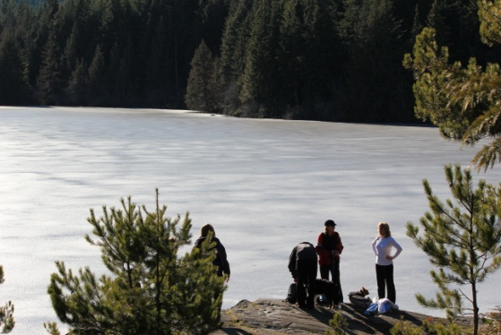BC Family Day Activities
* Emergency Room Life and Death at VGH- 6 part documentary

C:\Program Files (x86)\Microsoft Office\MEDIA\OFFICE12\Lines\BD14996_.gif

**CCHN Network Member Meetings-**

* **Next Our Cowichan Network Meeting –** Thursday February 13, 6:00 pm CVRD Board Room. Light meal at 5:30
* **Next Admin Committee Meeting** Wednesday February 19- 5:30 Committee Room 2 CVRD

C:\Program Files (x86)\Microsoft Office\MEDIA\OFFICE12\Lines\BD14996_.gif

**Upcoming Events/ Workshops/ Community Meetings**

**Ready To Rent Classes**

12 hour course over 6 weeks to support you to find and keep better housing

• Identify what landlords look for in choosing a tenant

• Learn some strategies to find the housing you need

• Figure out how to improve your rental references and your credit rating

• Learn your rights as renter.

**Are you Ready to Rent?**

**Direct Benefit: This course is viewed by some landlords as being like a letter of Reference**

**Literacy Cowichan**

213B 80 Station Street, Duncan

Classes are from 10:00 am to 12:00 pm every Thursday for six weeks

Feb 13th to March 20th, 2013

Please register with Kathleen at - 250-597-1776

**Classes will be offered at Ladysmith Resource Center**

630 – 2nd Avenue, Ladysmith

Classes are from 2:00 pm to 4:00 pm every Monday for six weeks

Feb 17th to March 24th, 2013

Please register with Cindy at 250-245-3079

**Cowichan Lake Community Services**

121 Point Ideal Rd.

Classes are from 10:30 am to 12:30 pm every Monday for six weeks

Feb 17th to March 24th, 2013

Please register at Community Services – 250-749-6822

C:\Program Files (x86)\Microsoft Office\MEDIA\OFFICE12\Lines\BD14996_.gif

**Great Resource on the Determinants of Health and Promoting Health Equity**

Although this is an American document it is well worth the read

[**http://www.cdc.gov/nccdphp/dch/programs/healthycommunitiesprogram/tools/pdf/SDOH-workbook.pdf**](http://www.cdc.gov/nccdphp/dch/programs/healthycommunitiesprogram/tools/pdf/SDOH-workbook.pdf)

C:\Program Files (x86)\Microsoft Office\MEDIA\OFFICE12\Lines\BD14996_.gif

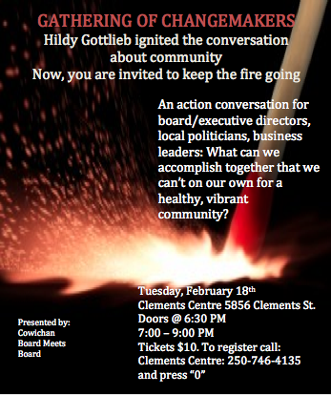

**C:\Program Files (x86)\Microsoft Office\MEDIA\OFFICE12\Lines\BD14996_.gif**

**Family Day is Monday February 10- The Civic Holiday is intended to celebrate families and communities. Take advantage of this special time and engage in one of the many FREE local activities taking place in your community!**

**Duncan: Cowichan Aquatic Centre Family Day** at the Cowichan Aquatic Centre.

Come join us for a **free swim and fitness day.**

Time of event: 1pm to 4pm

**Duncan: Island Savings Centre Family Day** at the Island Savings Centre.

**Our FREE** Family Day event is scheduled for Monday, February 10th and includes three great family opportunities. We have the **Free Family Day Skate from noon to 1:20pm, our FREE Family Day Stick & Puck from 1:30-2:50pm and a FREE Family Day Racquet Sports from noon until 3pm.**

We will have FREE hot chocolate for everyone as well as many opportunities to win prizes. All events are for all ages and we are encouraging families to come out to this great event!

**Lake Cowichan: Cowichan Lake Recreation**

Come join us for: **Free Family Day skating**, free admission, free skate rentals and free refreshments

Time of Event: 3:30 pm – 4:50 pm

**Mill Bay: Kerry Park Recreation**

Come join us for: **Free Family Day skating**.

At this special family focused skating session we will play a variety of on-ice games and give away prizes. We will also have an area of ice coned off for those learning to skate. Admission and skate rentals are free.

Time of Event: 1:00 pm – 2:15 pm

**Shawnigan Lake: Shawnigan Lake Village**.

Come join us for: **A variety of fun family activities.**

In conjunction with the Shawnigan Heritage Society, the Shawnigan Lake Community Centre will be offering activities in the heart of Shawnigan Lake Village offering Arts, Music, Crafts and a Road Hockey Tournament.

Time of event: 11 am – 2 pm

C:\Program Files (x86)\Microsoft Office\MEDIA\OFFICE12\Lines\BD14996_.gif

**Check it out!**

**Emergency Room: Life and Death at VGH**, a six-part documentary series challenges viewers with some of the most pressing health care issues right now.  Episodes were filmed at Vancouver General Hospital, and are made available online.  The documentary's interactive website also features discussion boards for healthy debate on current service and care issues, as well as pages for people to share their emergency care stories.  Check out the site and episodes of the documentary[**here**](http://er.knowledge.ca/). C:\Program Files (x86)\Microsoft Office\MEDIA\OFFICE12\Lines\BD14996_.gif

Do you have a resource, event or information you would like to share?

Send it to [cindylisecchn@shaw.ca](mailto:cindylisecchn@shaw.ca) and it will be included in the weekly Health Matters Newsletter