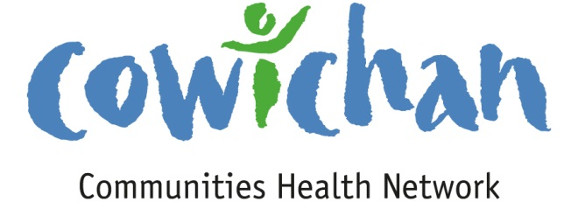

**CHECK UP**

February 22, 2013

Hello Everyone,

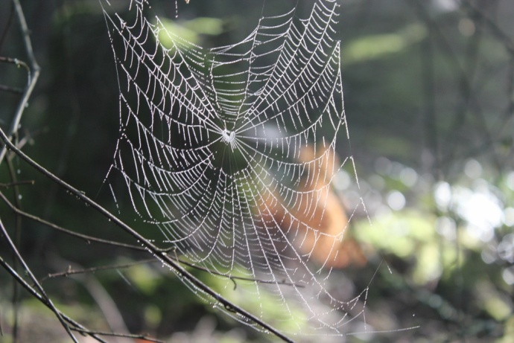It’s not so much about getting to the end of the trail but what you experience along the way. My teenage daughter captured these images on our hike on Mount Tzouhalem last weekend. (Even teenagers get it)!

On another note it was wonderful to see many CCHN members at the official opening of Cowichan Lodge. This has been a long journey and as Rob stated yesterday is bittersweet for some. This too was about what we learned along the way as well as getting to the end of the trail!

C:\Program Files (x86)\Microsoft Office\MEDIA\OFFICE12\Lines\BD14996_.gif

**Meetings**

None scheduled for the week of February 25th to March 1.

C:\Program Files (x86)\Microsoft Office\MEDIA\OFFICE12\Lines\BD14996_.gif

**Upcoming Events/ Workshops/ Community Meetings**

* **Patient Voices Determinants of Health Webinar- (See info in newsletter)**

***Please contact Cindy if you might be interested in getting a group together to view this webinar.***

**March 6, 12:00 to 1:00pm (PST):** Creating a Sustainable Health Care System: The Impact of Social Determinants of Health

**March 13, 12:00 to 1:00pm (PDT):** Health Care System Change: Barriers and Opportunities **[Reserve your spot.](http://patientvoices.us1.list-manage2.com/track/click?u=d1d2e9f5af38684626b6c2280&id=4fc2a9d9b8&e=e816ff589a" \t "_blank)**

* **Board Meets Board**

March 12, 2013 @ 5:30 pm New Life Baptist Church

1839 Tzouhalem Road Duncan BC

**Social Innovation: Building Upon Ideas**

Colleen McCormick Director of Innovative Partnerships, Ministry of Social

Development.

* We will focus on possibilities for connection and cooperation amongst community based social services, businesses, and local government in addressing key challenges facing our community and in building upon what is already working

***Cost: $15 per person To register:***

Must be paid in advance United Way Cowichan 1 Kenneth Place

Deadline for registration: In person: cheque or debit

March 7, 2013 By phone: 250-748-1312

Master Card, Visa, American Express

* **Cowichan Seniors Community Foundation AGM**

would like to invite you to attend our AGM on Tuesday,

March 12 at 5:30 pm.  
A brief meeting will be followed by refreshments and a social time in the Community Room at Thrifty Foods. Attached is a copy of the invitation with an RSVP request by phone

C:\Program Files (x86)\Microsoft Office\MEDIA\OFFICE12\Lines\BD14996_.gif

**Moose Hide Campaign..**

It is a grass roots movement of Aboriginal and Non Aboriginal Men who are standing up against Violence towards Aboriginal women and children.

The way it works is that an individual pins a tiny piece of moose hide to their lapels... similar to breast cancer awareness or the daffodil campaign. Wearing the moose hide signifies a commitment to honour, respect and protect the women and children in your life and work together with other men to end violence. It is hoped that the campaign will spread across Canada.

They have a website that provides more information

[www.moosehidecampaign.ca](http://www.moosehidecampaign.ca)

C:\Program Files (x86)\Microsoft Office\MEDIA\OFFICE12\Lines\BD14996_.gif

**Join us at the upcoming My Tween & Me training!**

**Date:** May 15 & 16, 2013

**Location:** Van Dusen Botanical Garden, Vancouver BC

**Cost:** Early Bird Rate $360 for 2 days (Early bird rate ends March 15th. Reg rate $400)

[**REGISTER NOW!**](http://r20.rs6.net/tn.jsp?e=001RF3uc9Sm6QPM1Y0UXqtx0UhiVeo4jsr9Hr92EoGaQ0H6eqdjod-1gYG3fL5bKohLG5uFIV2NJElR877RS-hKaOdHLv-kdqJwn25XZFpCLgJCMA1dFPdbhzRthhUzUgjAyCUS8JNgMh7ghXVBmoIioOl0LLtfzXi6l8AXrm2nFhtl24CcI9KqoQ==)

This interactive, two-day training session prepares program leaders to deliver the [**My Tween and Me**](http://r20.rs6.net/tn.jsp?e=001RF3uc9Sm6QOVHsqW5_Uw854f0i4r80uIczNedVV_UUJsz8-UbyHnIycd9CNaOW-TEWBmGNTwRkxuqzVE7oAXO1B1zc3eHkhpI03fXQTglCn7fHHYKTtskUTA0sbpOQhVY901uWTA5-3wYhdWcYhTrj1obRUIXPb_) parenting program. Get the tools and know-how to help parents maintain a strong connection with their children as they move into the teen years.

After attending this training you will have developed:

* Increased knowledge of tweens' developmental milestones
* Awareness of risk and protective factors that affect children as they move through the tween years and into adolescence
* Strengthened understanding of the issues parents of tweens face in diverse cultural and linguistic communities in BC
* Enhanced practical skills to help parents strengthen their relationships with their pre-teens

Packed with information, discussion and activities, the My Tween and Me leader training session incorporates current research along with practical communication skills for parents.

C:\Program Files (x86)\Microsoft Office\MEDIA\OFFICE12\Lines\BD14996_.gif

|  |  |  |  |  |
| --- | --- | --- | --- | --- |
| |  |  |  |  | | --- | --- | --- | --- | | |  |  |  | | --- | --- | --- | | |  | | --- | | Two webinars on the social determinants of health. |  |  | | --- | | [View this email in your browser](http://us1.campaign-archive1.com/?u=d1d2e9f5af38684626b6c2280&id=6c18af48d2&e=e816ff589a) | | | |
| |  |  |  | | --- | --- | --- | | |  |  | | --- | --- | | |  | | --- | | http://gallery.mailchimp.com/d1d2e9f5af38684626b6c2280/images/pvn_newsletter_logo.gif | | | |
| |  |  |  | | --- | --- | --- | | |  |  | | --- | --- | | |  | | --- | | Social Determinants of Health How do we help all citizens live healthy lives? How do we make our health care system sustainable for the long term? How do we ensure that every person is able to make the best choice they can when it counts? Recent research indicates that beyond access to medications and quality medical treatment, a person’s living conditions is the top factor affecting their health. Education, employment, income level and other important considerations have come to be known as the Social Determinants of Health.  In the upcoming two webinars Dr John Millar will be discussing a population health approach that takes into consideration the social determinants of health and the adjustments in our health care system that are required to adopt this approach.   * **March 6, 12:00 to 1:00pm (PST):** Creating a Sustainable Health Care System: The Impact of Social Determinants of Health * **March 13, 12:00 to 1:00pm (PDT):** Health Care System Change: Barriers and Opportunities   [**Reserve your spot.**](http://patientvoices.us1.list-manage2.com/track/click?u=d1d2e9f5af38684626b6c2280&id=4fc2a9d9b8&e=e816ff589a)  Dr Millar is a Clinical Professor at the School for Population and Public Health at UBC where he is involved in teaching and research in public health leadership, health policy and international health. Dr Millar is currently Vice President of the Public Health Association of BC.  Among other outstanding achievements Dr Millar has developed the Health Goals for BC as the Provincial Health Officer from 1992- 1998. He has also served as the Vice President for the Canadian Institute for Health Information and the Executive Director for the Population and Public Health for the BC Provincial Health Services Authority.  If you have any questions about the webinar please contact Oleg Lungu at [olungu@impactbc.ca](mailto:olungu@impactbc.ca) or 604.742.1772 ext 232. | | | |
| |  |  |  |  | | --- | --- | --- | --- | | |  | | --- | |  | | |  | | --- | |  | | |
| |  | | --- | |  | |





**RESPECT & COMPASSION – WORKSHOP**

**When? March 2nd - 8am to 2pm**

**Where?** West Coast Men’s Support Society Office (see below for address)

**What? A place for men to learn healthy communication with self & others:**

* Introduction – Communication & Connection = The Glue of Relationships – Discussion
* Compassionate Communication – unique qualities? Key elements? Steps?
* How to transition our communication from our head to our heart? Why is this important? Impact on ourselves and others?
* What is respect? How does respectful communication look? Impact?
* Slow Communication – What? Why? How? Impact?
* Active Listening – Discussion around importance of presence
* The Power of Empathy – Why is it empowering?
* Concluding Remarks – How will this workshop support men in our communities? Do you know men who this could support presently? Discussion & Feedback.

**Please RSVP so that we know how much food to order. Thanks!**

**Donations appreciated!**

**213-80 Station St., Duncan, BC V9L 1M4 Canada   
Phone (250) 597-2801 TOLL FREE: (855) MEN WORK (636-9675)**

C:\Program Files (x86)\Microsoft Office\MEDIA\OFFICE12\Lines\BD14996_.gif

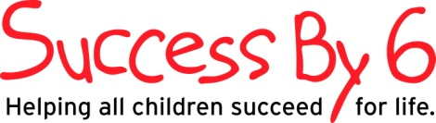

*The vision of Success By 6 is to build the capacity of parents and communities to support children ages 0 to 6 to become healthy, safe, secure, successful learners, socially engaged and responsible so they are ready to succeed in school and in life.*

**CALL FOR PROPOSALS**

Community Based Social Services and organizations of the Cowichan Valley are invited to submit proposals for receipt of the Success By 6 Strategic Implementation Funds.

There is $35,000 of Strategic Implementation Funds for 2012 to build the capacities of parents; families and child care providers in making a difference in the social and emotional development of young children.

Research, community forums and the Early Development Instrument (EDI) results have identified that one of the priorities for the Cowichan Valley is to improve and support the social and emotional development of our children.

The goal of this call for proposals is to raise awareness of the importance of the early years and to increase public support for early childhood development as a community priority.

The request for funds and your proposal must signify how you plan to support the social and emotional development or health of children and families within the Cowichan Region.

All proposals must be completed by **noon, Thursday, March 14th 2013**

Email submissions to:

[cowichansuccessby6@shaw.ca](mailto:cowichansuccessby6@shaw.ca)

Or

Hard copies may be delivered to Cowichan Success By 6 c/o

1 Kenneth Place

Duncan BC, V9L-5G3

Please contact Laura Court to answer any question [cowichansuccessby6@shaw.ca](mailto:cowichansuccessby6@shaw.ca) or call 250-701-3647 for more information.

