CHECK UP
August 9, 2013
The view from Bald Mountain looking down at Lake Cowichan is worth the adventure. The Boy Scout trail is not difficult as it switches back and forth up the mountain. The trail is clearly marked. Enter off of Marble Bay road via Meades Creek Road. (See map below)
Finish with a swim in the lake at the quaint Marble Bay Park about 100 metres from the trail head.
Today’s Check up Includes:

- Meeting Schedules
- Community meetings and events
- Underlying Premise Evidence- (part 4) Employment/ Working Conditions
- 1 in 8 Families Struggle with Food insecurity
- Mark your Calendars for Cities Fit for Children Conference
- Map to Bald Mountain
CCHN Network Member Meetings-
- Next Admin Committee Meeting September 9th 5:30 pm
- Next CCHN Meeting September 12th, Dinner at 5:30 Meeting Starts at 6:00 CVRD Board Room
Upcoming Events/ Workshops/ Community Meetings
- Choose Cowichan Lake- August 15 6:30 pm at Lake Cowichan City Hall
- RCMP Musical Ride
When: August 16 2013
Time: | 2:00 pm
Where: | Avalon Equestrian Centre 2442 Herd Road
ONE SHOW ONLY IN DUNCAN Gates open 2pm (community groups and food vendors on site) Preshow 4pm and Ride at 5pm. Festival Style seating - bring your won lawn chairs or blankets. Follow traffic directions on Herd to Norcross Road main gates - if handicap placard in place, use the Herd Rd driveway. Pre-purchase of tickets recommended through Cowichan Ticket Centre 2687 James ST 250-748-7529. Only $10 pp - children under 5 Free - family of 4 $30.
Limited number at the gate CASH only and All tickets will be $15 www.warmlandcops.com

KEY DETERMINANT – 4 Employment / Working Conditions
UNDERLYING PREMISES
EVIDENCE
Unemployment, underemployment, stressful or unsafe work are associated with poorer health.
People who have more control over their work circumstances and fewer stress related demands of the job are healthier and often live longer than those in more stressful or riskier work and activities.
Evidence from the Second Report on the Health of Canadians:
- Employment has a significant effect on a person's physical, mental and social health. Paid work provides not only money, but also a sense of identity and purpose, social contacts and opportunities for personal growth. When a person loses these benefits, the results can be devastating to both the health of the individual and his or her family. Unemployed people have a reduced life expectancy and suffer significantly more health problems than people who have a job.
- Conditions at work (both physical and psychosocial) can have a profound effect on people's health and emotional well-being.
- Participation in the wage economy, however, is only part of the picture. Many Canadians (especially women) spend almost as many hours engaged in unpaid work, such as doing housework and caring for children or older relatives. When these two workloads are combined on an ongoing basis and little or no support is offered, an individual's level of stress and job satisfaction is bound to suffer. Between 1991 and 1995, the proportion of Canadian workers who were "very satisfied" with their work declined, and was more pronounced among female workers, dropping from 58% to 49%. Reported levels of work stress followed the same pattern. In the 199697 NPHS, more women reported high work stress levels than men in every age category. Women aged 20 to 24 were almost three times as likely to report high work stress than the average Canadian worker.
Evidence from Investing in the Health of Canadians:
- A major review done for the World Health Organization found that high levels of unemployment and economic instability in a society cause significant mental health problems and adverse effects on the physical health of unemployed individuals, their families and their communities.
New report finds one in eight Canadian households struggle with food insecurity (From First Call)
The first in a new series of annual reports on food insecurity in Canada has been released by PROOF. The report finds that almost 3.9 million Canadians, or nearly one in eight households, experienced some level of food insecurity in 2011, including 1.1 million children. The highest rates of food insecurity were found in Canada’s North and the Maritimes.
Households with children under the age of 18 were more likely to be food insecure than households without children. In British Columbia the proportion of children who lived in food insecure households was 15.3%, compared to the national average of 17%. Newfoundland and Labrador stood out as the province with the lowest overall rate of food insecurity (10.6%) and as the only province that has seen a sustained decline in this number over the observed period (2005-11).
The full report from PROOF is available here.
Cities Fit for Children Conference (Surrey)
November 21 – 23, 2013, Sheraton Guildford Hotel, Surrey
This year’s Cities Fit for Children Conference theme is the Rights of the Child, and will include workshops on:
• healthy built environments,
• programs and services, and
• meaningful civic engagement
Early Bird registration rate of $195 until September 20 ($225 after).
Registration and workshop information coming soon!
More conference information can be found here.
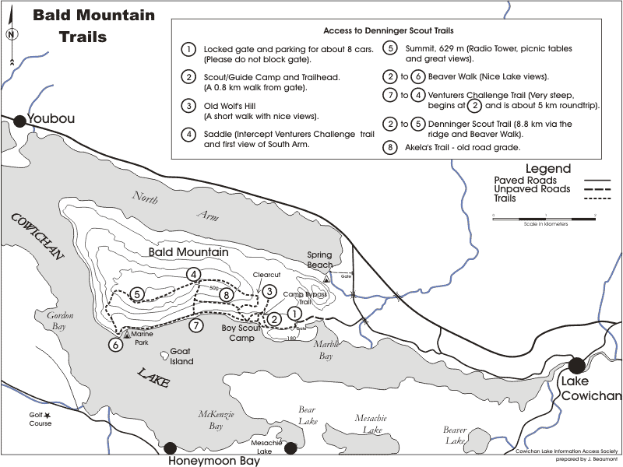

Map of Bald Mountain... just in case you want to venture out. Click on the image to expand it.

Do you have a resource, event or information you would like to share?
Send it to cindylisecchn@shaw.ca and it will be included in the weekly
Check UP Newsletter.

