****

**Health Matters**

**April 4, 2014**

**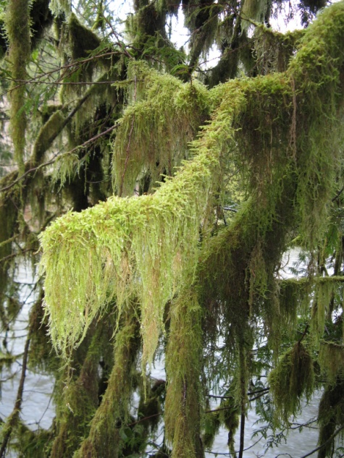Today’s Check up Includes:**

* Meeting Schedules
* Community meetings and Events
* Health Survey- Link for sharing broadly
* How to Never Grow Old- event
* Tri Cities approach physician shortages
* Ready Set Learn in your community

C:\Program Files (x86)\Microsoft Office\MEDIA\OFFICE12\Lines\BD14996_.gif

**Our Cowichan- Network Member Meetings-**

* **Next Admin Committee Meeting-** Wednesday April 17, 5:30 pm CVRD committee room 2
* **Next Our Cowichan Network Meeting –**Thursday May 8, CVRD Board Room. Light dinner at 5:30 pm – Meeting starts at 6:00 pm

C:\Program Files (x86)\Microsoft Office\MEDIA\OFFICE12\Lines\BD14996_.gif

**Upcoming Events/ Workshops/ Community Meetings**

* **Cowichan Aboriginal Festival of Film and Art-** April 23-26 at the Cowichan Theatre. Tickets at Cowichan Ticket Centre- Films- Workshops- Art- Performance- Focus Groups- Youth Awards Night- for more info go to [www.aff.cowichan.net](http://www.aff.cowichan.net)

C:\Program Files (x86)\Microsoft Office\MEDIA\OFFICE12\Lines\BD14996_.gif

**Cowichan Health Survey**

**WE WANT TO HEARFROM YOU!**

The purpose of this survey is to collect information from the communities served by ***Our Cowichan Communities Health Network*** to gain a better understanding of the current health and wellness of our residents. The information collected will be used to develop a Community Health Profile for the Cowichan region. This profile will ultimately be used to identify where we are doing well as well as gaps or barriers that impact health.  We will learn from this information and will work together to find community based solutions to improve the health of our communities and residents.

***We kindly ask that you complete the survey and that you share this link far and wide across the Cowichan Region.*** *( A pdf version has also been attached for you to print )*

**YOUR SURVEY RESPONSE WILL BE ANONYMOUS**

<http://fluidsurveys.com/s/CowichanCommunityHealthSurvey/>

C:\Program Files (x86)\Microsoft Office\MEDIA\OFFICE12\Lines\BD14996_.gif

**How to Never Grow Old**

Saturday April 12th, 2014 - 1:30 PM to 4:30 PM

**Cost:** At the Door: $15.00   
**Location:** [Duncan United Church](http://www.harbourliving.ca/venue/duncan-united-church/) 246 Ingram St, Duncan

**More Info:** Ruth Fenner [landrfenner@shaw.ca](mailto:landrfenner@shaw.ca) 250-246-2120 –

"How to Never Grow Old." With a great deal of humour and a little pathos, Pat Nichol, shares the secrets that she has learned about living every day to the maximum. She talks about age from a George Carlin perspective; doing things to live life to the fullest; she talks about our purpose in being here and shares stories from people who have made a difference. Her purpose is to be sure that you take a warriors approach to life and participate joyfully. She will share tips on how to attract new friends, ways to have a mini face lift and burn calories. Her purpose is to make you laugh, make you enjoy each moment of your life. To learn that life is too short not to eat dessert first.

C:\Program Files (x86)\Microsoft Office\MEDIA\OFFICE12\Lines\BD14996_.gif

**Article on Physician Shortages and the Tri Cities Approach**

<http://www.tricitynews.com/news/253961911.html>

C:\Program Files (x86)\Microsoft Office\MEDIA\OFFICE12\Lines\BD14996_.gif

****

**Ready, Set, Learn** -Ready, Set, Learn is a ‘Drop-in’ Educational and Health Fair helping your preschooler get ready for school. For Families and Children Ages 3-5 years.

**Friday April 4th at Chemainus Community School,**

**Thursday, April 10th at Shawnigan Lake Community Centre,**

**Thursday, April 17th at Duncan Mall,**

**Thursday April 24th at Palsson Elementary School.**

**Receive information on:** **Participate With Your Child In:**

Health & Nutrition Language Centres

Dental Play Centres

Vision Math Centres

Child Development Reading Centres

Language Development Story Times

Social & Emotional Development Music Times

Childcare & Pre School Programs

Success By 6

C:\Program Files (x86)\Microsoft Office\MEDIA\OFFICE12\Lines\BD14996_.gif



Do you have a resource, event or information you would like to share?

Send it to [cindylisecchn@shaw.ca](mailto:cindylisecchn@shaw.ca) and it will be included in the weekly Health Matters Newsletter