

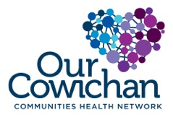

**Health Matters Newsletter**

**January 21, 2021**

**Today’s Health Matters Includes:**

* OCCHN Meeting Schedule
* Community Meetings
* Get Vaccinated- Resources are stretched please be patient when seeking booster shot or testing
* Help Develop a CVRD Active Transportation Plan
* Volunteer Counselling Training Opportunity
* Free COVID Screening Resources
* Make February a 5-2-1-0 Month
* Primary Care Survey is Still Open- $100 prize
* Parenting Without Power Struggles



* **Next Admin Committee Meeting** February 3-4:00 pm **zoom call**
* **Next Our Cowichan Network Meeting Postponed until further notice**
* **Next EPIC Committee Meeting-** February 17, 2022, 1:30 pm-3:00 pm **zoom call**
* **Cowichan CAT –** January 27 2022, 10 am -nooncontact Leah Vance Leah Vance[**leahlcvance@gmail.com**](mailto:leahlcvance@gmail.com)for access



**Omicron is Circulating Please GET Vaccinated**

Resources are being pushed to the limit. Please be patient with accessing vaccination appointments and COVID testing.

In the event that there are no vaccine appointments showing on the booking site you can return to the site at a later time and more appointments will be opened up. (*Not all appointments are placed on the site daily and are done in increments*). Pharmacies may only post openings a few days in advance. More appointment openings are updated daily so please keep checking.

[B.C.'s response to COVID-19 - Province of British Columbia (gov.bc.ca)](https://www2.gov.bc.ca/gov/content/covid-19/info/response)

**Everyone 18 years and older will be invited to get a booster dose of the COVID-19 vaccine, starting with people most at risk.**

* [Learn about booster doses](https://www2.gov.bc.ca/gov/content/covid-19/vaccine/booster)s



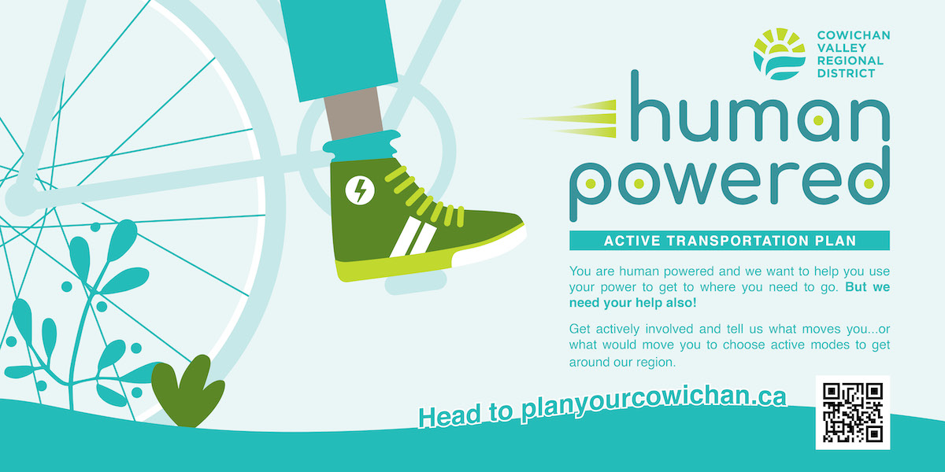



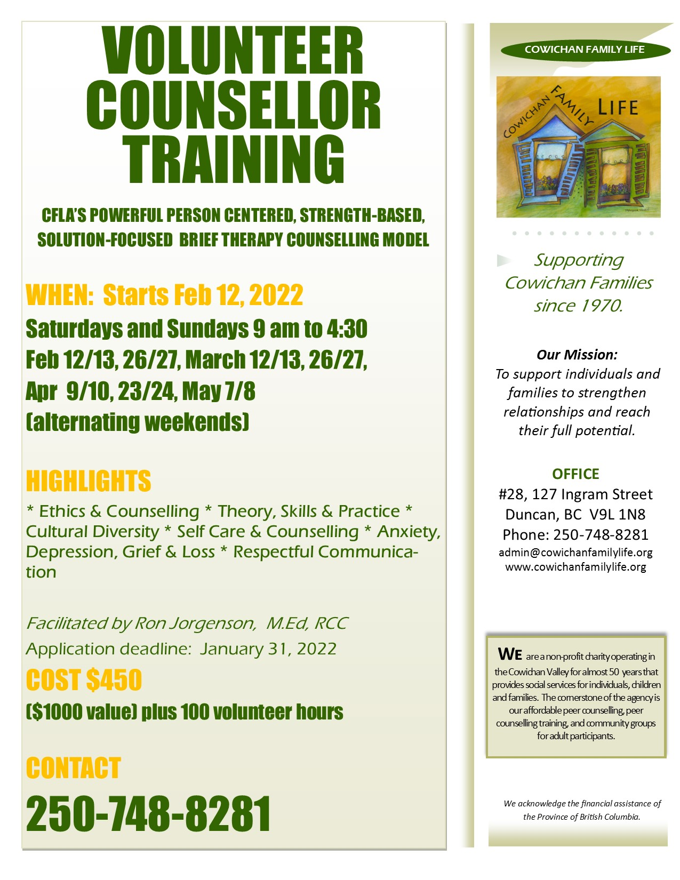

**Free COVID 19 Tests and Screening Resources**

The Canadian Red Cross is helping to keep organizations and communities safer through the [Stop the Spread and Stay Safe! program: COVID-19 Screening for Community Organizations](https://fcssbc.us10.list-manage.com/track/click?u=066d9728e61b736228ff0c333&id=ce37a86013&e=be4ad57c5a). Non-profits, charities, and Indigenous community organizations with frontline workers in British Columbia may be eligible. [You can learn more and apply for the program here](https://fcssbc.us10.list-manage.com/track/click?u=066d9728e61b736228ff0c333&id=1010be0242&e=be4ad57c5a).



**Let’s Make February a 5-2-1-0 Month!** Here are the guidelines to Implement with Children and Youth. A month of repeating an activity can make this a healthy lifelong habit.

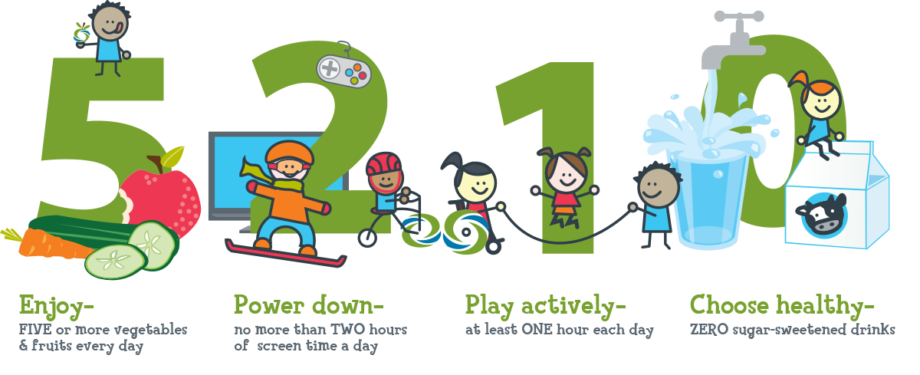



**Prize Draw Coming Soon- Primary Care Survey Is Still Open**

Got a minute? We want to hear from you!

***"Everyone who completes the survey and who provides their email address will be entered in a draw to win a gift basket (estimated value of $100). The next draw will happen on January 31, 2022."***

The Cowichan Primary Care Network is launching a survey to better understand whether the healthcare needs and preferences of the people who live in the Cowichan Valley are being supported. Your feedback will help us understand what’s missing and how we might make it better. All your answers on the survey will remain confidential and anonymous.

If you have any questions about the survey, please do not hesitate to contact Deborah Rutman or Carol Hubberstey at: [notabenegroup@shaw.ca](mailto:notabenegroup@shaw.ca).

Please find the link to the survey here:  <https://survey.alchemer-ca.com/s3/50135829/Patient-Experience-Survey-Online-version>







**Health Matters Newsletter**

**Do you have a resource, event or information you would like to share?**

Send it to [cindylisecchn@shaw.ca](mailto:cindylisecchn@shaw.ca) and it will be included in the Friday Newsletter